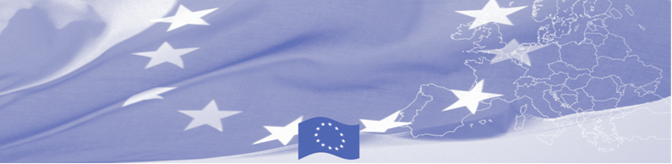
PRESS RELEASE

For release on March 14 , 2016

BOMCA 9 supports professionalism in travellers profiling and identification

The EU is continuing to offer significant support to border security activities in Central Asia. In particular, on March 14 – 16 Bishkek will host the National workshop on identification and profiling techniques, conducted within the framework of the EU-funded Border Management in Central Asia Programme (BOMCA 9) in cooperation with UNHCR Representation in the Kyrgyz Republic. The workshop, facilitated by the EU expert from the State Border Guard of Latvia, will gather border guards and other law enforcement professionals of the Kyrgyz Republic, involved in profiling and identification of different groups and categories of travelers.

This workshop is a part of BOMCA 9 activity directed to improvement of legal and procedural instruments to manage both regular and irregular migration at borders, and to face current challenges in identification of persons which may pose a risk to the public order and security. It aims to present EU good practices in the area of identification and profiling of different groups of travelers and to introduce modern mechanisms in profiling different categories of persons crossing the state border. The workshop participants will exchange experience and best practices on profiling and its main modern directions and approaches to travellers identification at the border crossing points, including criminal profiling, information comparative analysis, documents check and profile development methods. Several tools for classification of travellers, such as first impression, people habitology and characteristics, migrant’s appearance, reaction to suspicious behaviour will be discussed in theory and consolidated in practice through practical exercises and group work.

Such workshops are planned to be conducted in all 5 Central Asian countries and based on its results the EU experts will develop recommendations for aligning existing profiling and identification mechanisms at the national level with the international standards and best practices.

First BOMCA operations began in Central Asia in 2003, and since then, BOMCA has strengthened partnership of the Central Asia Governments in the field of border management. The European Union allocated a sum of EUR 33.6 million to BOMCA for the period of 2003 – 2014 and almost EUR 5 million for its 9th implementation phase (2015 - 2018).

For more information please contact Ms. Janna Tashieva, BOMCA Regional Communications Officer – + 996 312 394071 or janna.tashieva@icmpd.org
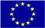  The Programme is imple-mented by the Consortium of partners led by the State Border Guard of the Republic of Latvia:  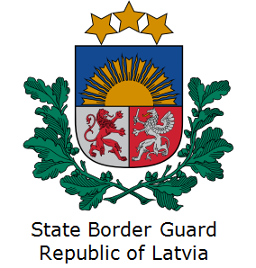 | This Programme is funded by the European Union  Delegation of the European Union to the Kyrgyz Republic  21 Erkindik Boulevard, Business Centre Orion, 5th floor  Bishkek, 720040, Kyrgyz Republic  Telephone: +996 312 26 10 00  Fax: +996 312 26 10 07  E-mail: delegation-kyrgyzstan@eeas.europa.eu  Website:http://eeas.europa.eu/delegations/  kyrgyzstan  Facebook:http://www.facebook.com/eudelkg | The European Union is made up of 28 Member States who have decided to gradually link together their know-how, resources and destinies. Together, during a period of enlargement of 60 years, they have built a zone of stability, democracy and sustainable development whilst maintaining cultural diversity, tolerance and individual freedoms. The European Union is committed to sharing its achievements and its values with countries and peoples beyond its borders.

