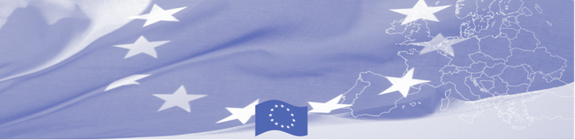
PRESS RELEASE

People working at borders through the eyes of child. BOMCA sums up the results of drawing competition.
For release on 01 July 2016

On July 1st, the European Union Delegation hosts an Award Ceremony for the drawing contest “People working at borders”, held in the framework of the Border Management Programme in Central Asia. The competition was announced on May, 15 2016 and invited children (9-14 y.o.) to present their vision on border guards’ work and daily life in an artistic way.

The wider objective of the contest was to deepen understanding of the general public of the work of the border guard agencies - to facilitate the positive attitude of children towards people carrying duties at borders, to express their understanding of the professionalism and cooperation of people working at borders while at the same time to encourage children to demonstrate their talents and creativity

In total, 119 drawings were received by BOMCA Office in Kyrgyzstan from the whole country. “It was very difficult to choose the winners. Each child’s drawing, submitted for the competition, is unique and deserves an award. We are very pleased to see such a dedication from so many talented children”, says Raitis Tiliks, BOMCA Regional Manager.

But it is time to sum up the results and congratulate the winners! The selecting committee, consisting of the representatives of the European Union, BOMCA programme and State Border Service of the Kyrgyz Republic, unanimously selected the winners : 1st place - Dastan Djamaev (12 y.o, Osh city), 2nd place - Aziz Degenbaev (10 y.o, Bishkek), 3rd place - Eldana Chyimylova (9 y.o Bishkek). In addition to the main awards, more than 20 children will be given honorary awards, drawing kits and special prizes from the BOMCA Regional Manager personally. Each participant will receive a certificate of appreciation.

First BOMCA operations began in Central Asia in 2003, and since then, BOMCA has strengthened partnership of the Central Asia Governments in the field of border management. The European Union allocated a sum of EUR 33.6 million to BOMCA for the period of 2003 – 2014 and almost EUR 5 million for its 9th implementation phase (2015 - 2018).

  The Programme is imple-mented by the Consortium of partners led by the State Border Guard of the Republic of Latvia:  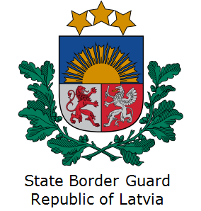 | This Programme is funded by the European Union  Delegation of the European Union to the Kyrgyz Republic  21 Erkindik Boulevard, Business Centre Orion, 5th floor  Bishkek, 720040, Kyrgyz Republic  Telephone: +996 312 26 10 00  Fax: +996 312 26 10 07  E-mail: delegation-kyrgyzstan@eeas.europa.eu  Website:http://eeas.europa.eu/delegations/  kyrgyzstan  Facebook:http://www.facebook.com/eudelkg | The European Union is made up of 28 Member States who have decided to gradually link together their know-how, resources and destinies. Together, during a period of enlargement of 60 years, they have built a zone of stability, democracy and sustainable development whilst maintaining cultural diversity, tolerance and individual freedoms. The European Union is committed to sharing its achievements and its values with countries and peoples beyond its borders.

