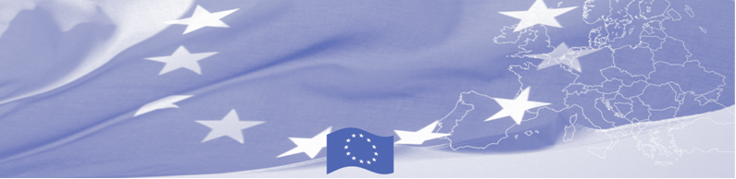
PRESS RELEASE

The State Border Service of Kyrgyzstan receives personal protective equipment
against COVID-19 through the EU-funded BOMCA Programme

Bishkek, 20 July 2020

In response to the COVID-19 pandemic, the European Union, through its Border Management Programme in Central Asia (BOMCA), is handing over personal protective equipment (PPE) to the State Border Service of the Kyrgyz Republic. The PPE includes 2000 KN95-filtering respirators, 2000 nitrile gloves, 800 litres of antiseptics, 50 face shields and 300 full-body gowns, which will now be distributed to the border guard units.

“At the moment, there is an unprecedented demand and urgent need for materials to help limit the spread of the coronavirus pandemic in Kyrgyzstan. These include personal protective equipment for those at increased risk of exposure in the course of their daily work duties. Border guards are the first points of contact to meet at the border checkpoints in the country. The supplied protective items will contribute to the agency’s capacity to ensure the safe processing of people and goods crossing the border under COVID-19 conditions.” – said Ambassador Eduard Auer, Head of the Delegation of the European Union to the Kyrgyz Republic.

The EU-funded BOMCA Programme continues to support the Central Asian border authorities in addressing the COVID-19 impact through webinar trainings and supply of protective equipment.

The first BOMCA operations in Central Asia began in 2003, and since then, BOMCA has strengthened the partnership with Central Asian Governments in the field of border management. The European Union allocated EUR 40.1 million to BOMCA for the period of 2003 – 2020; out of this amount, EUR 6.6 million was assigned to its 9th implementation phase (2015 - 2020).
For more information, please contact BOMCA Regional Office at bomca@icmpd.org

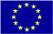  The Programme is implemented by the Consortium of partners led by the State Border Guard of the Republic of Latvia:  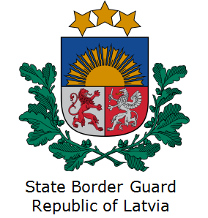 | This Programme is funded by the European Union  Delegation of the European Union to the Kyrgyz Republic  21 Erkindik Boulevard, Business Centre Orion, 5th floor  Bishkek, 720040, Kyrgyz Republic  Phone number: +996 312 26 10 00  Email: delegation-kyrgyzstan@eeas.europa.eu  Website: https://eeas.europa.eu/delegations/kyrgyz-republic | The European Union is made up of 28 Member States who have decided to gradually link together their know-how, resources and destinies. Together, during a period of enlargement of 60 years, they have built a zone of stability, democracy and sustainable development whilst maintaining cultural diversity, tolerance and individual freedoms. The European Union is committed to sharing its achievements and its values with countries and peoples beyond its borders.

