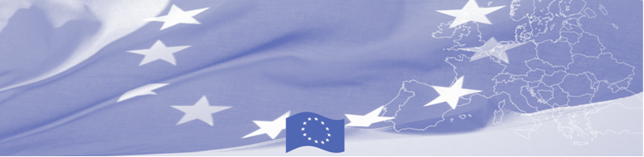
PRESS RELEASE

The EU-BOMCA Programme delivers personal protective equipment to the
Border Management Agencies of Kazakhstan

Nur-Sultan, 17 July 2020

As part of European Union’s (EU) assistance to Kazakhstan’s COVID-19 response efforts, the EU-funded Border Management Programme in Central Asia (BOMCA) handed over today the essential personal protective equipment to the Border Service of the National Security Committee, State Revenue Committee of the Ministry of Finance and Veterinary Committee of the Ministry of Agriculture of the Republic of Kazakhstan. The equipment includes 150 sets of full-body protective suits (gowns, face shields, respirator masks, boot covers, gloves), and six handheld medical thermal imagers.
“As the situation with the COVID-19 continues to evolve, the personal protective equipment play a crucial role in ensuring that the personnel placed at the forefront of the efforts to respond to the spread of coronavirus are fully protected. The border guards, customs and veterinary-sanitary officers are the first responders, who are working hard to ensure the uninterrupted supply of critical goods and expedite the border clearances during the ongoing COVID-19 emergency.” - said Sven-Olov Carlsson, Ambassador of the European Union to the Republic of Kazakhstan.
The EU-BOMCA Programme is committed through partnerships with Central Asian Governments to support and equip the Border Management Agencies for advancing their capacities in response to the COVID-19 pandemic.
The first BOMCA operations in Central Asia began in 2003, and since then, BOMCA has strengthened the partnership with Central Asian Governments in the field of border management. The European Union allocated EUR 40.1 million to BOMCA for the period of 2003 – 2020; out of this amount EUR 6.6 million was assigned to its 9th implementation phase (2015 - 2020).
For more information, please contact BOMCA Regional office in CA at bomca@icmpd.org

The Programme is implemented by the Consortium of partners led by the State Border Guard of the Republic of Latvia:  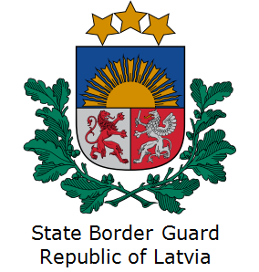 | 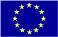  This Programme is funded by the European Union  Delegation of the European Union to the Republic of Kazakhstan  Kosmonavtov St. 62, 7th floor  Z05E9E1, Nur-Sultan, Kazakhstan  Phone number: +7 7172 974540  Email:  Delegation-Kazakhstan@eeas.europa.eu | The European Union is made up of 27 Member States who have decided to gradually link together their know-how, resources and destinies. Together, during a period of enlargement of 60 years, they have built a zone of stability, democracy and sustainable development whilst maintaining cultural diversity, tolerance and individual freedoms. The European Union is committed to sharing its achievements and its values with countries and peoples beyond its borders.

