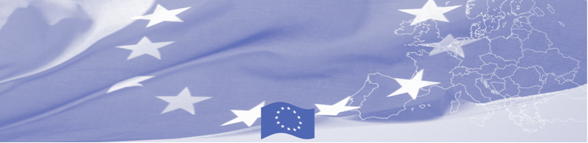
PRESS-RELEASE

For release on June 8, 2016

Dushanbe is hosting a national workshop on compatibility of customs legislation applied in the Republic of Tajikistan with the provisions of the revised Kyoto Convention.

A workshop on compatibility of customs legislation applied in Tajikistan with the provisions of the revised Kyoto Convention started on 8 June in Dushanbe, gathering national experts from the Customs Service under the Government of Tajikistan dealing with customs control arrangement, customs clearance and tariff regulation, legal issues and risk management. The workshop is conducted within the framework of Border Management in Central Asia Programme (BOMCA), funded by the European Union.

During this three days activity invited EU experts together with the national customs officers will discuss international standards and principles for advanced and effective customs control set out in revised Kyoto Convention, in particular related to customs control arrangement at the checkpoints, declaration of goods, payment of customs duties and taxes. As the result of the workshop a comparative analysis including recommendations will be prepared, which will reflect compatibility of customs legislation applied in Tajikistan with the provisions of the Revised Kyoto Convention.

First BOMCA operations began in Central Asia in 2003, and since then, BOMCA has strengthened partnership of the Central Asia Governments in the field of border management. The European Union allocated a sum of EUR 33.6 million to BOMCA for the period of 2003 – 2014 and almost EUR 5 million for its 9th implementation phase (2015 - 2018). The overall objective of the current phase of the Programme, which is to increase effectiveness and efficiency of border management in Central Asia, will be reached by introducing advanced elements of the Integrated Border Management (IBM), assisting governments in developing and reforming their migration governance, mobility and trade facilitation policies and strengthening capacities of Border and Migration Agencies.

For more information please contact BOMCA in Tajikistan – +992 43 3779708 or jafar.usmanov@icmpd.org

  The Programme is imple-mented by the Consortium of partners led by the State Border Guard of the Republic of Latvia:  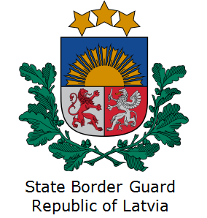 | This Programme is funded by the European Union  Delegation of the European Union to  Tajikistan  74 Adhamov street  734013 Dushanbe  Republic of Tajikistan  Phone: +992 37 221-74-07  Fax: +992 37 221-43-321  E-mail: Delegation-Tajikistan@eeas.europa.eu | The European Union is made up of 28 Member States who have decided to gradually link together their know-how, resources and destinies. Together, during a period of enlargement of 60 years, they have built a zone of stability, democracy and sustainable development whilst maintaining cultural diversity, tolerance and individual freedoms. The European Union is committed to sharing its achievements and its values with countries and peoples beyond its borders.

