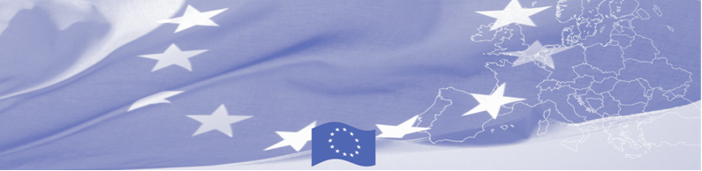
PRESS RELEASE

BOMCA is providing 7 000 specialized protective medical sets to border agencies of Tajikistan

Dushanbe, 13 April 2020

Due to the rapid spread of the virus worldwide, EU-funded Border Management in Central Asia Programme (BOMCA) supports the border management agencies in Tajikistan in undertaking prevention measures against the COVID-19 outbreak. BOMCA is delivering 3 500 specialized protective medical sets (masks and gloves and antiseptic liquids) to the Border Troops of State Committee for National Security and 3 500 sets to State Committee for Food Security. Protective sets will be used by border officers serving at the border, allowing them to safely perform their duties and to prevent possible contamination and further spreading of the virus.

The first BOMCA operations in Central Asia began in 2003 and, since then, BOMCA has strengthened the partnership between Central Asian Governments in the field of border management. The European Union allocated a sum of EUR 40, 1 million to BOMCA for the period of 2003 – 2019, out of which EUR 6, 6 million were assigned to its 9th implementation phase (2015 - 2019).

For more information, please contact Mr. Mustafo Mamadnazarov, BOMCA National Coordinator in Tajikistan – +992-8877-2004 or, mustafo.mamadnazarov@icpmd.org

  The Programme is implemented by the Consortium of partners led by the State Border Guard of the Republic of Latvia:  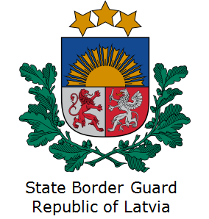 | This Programme is funded by the European Union  Delegation of the European Union to the Republic of Tajikistan  74 Adhamov street 734013 Dushanbe,  Republic of Tajikistan  Phone number:  (+992 37) 221 74 07  Email:  Delegation-Tajikistan@eeas.europa.eu | The European Union is made up of 28 Member States who have decided to gradually link together their know-how, resources and destinies. Together, during a period of enlargement of 60 years, they have built a zone of stability, democracy and sustainable development whilst maintaining cultural diversity, tolerance and individual freedoms. The European Union is committed to sharing its achievements and its values with countries and peoples beyond its borders.

