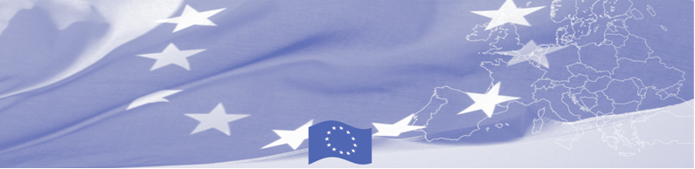
PRESS RELEASE

Support to Food Security Committee of Tajikistan in drafting its Development strategy

Dushanbe, 03 March 2020

BOMCA technical assistance mission continues its work in Dushanbe starting from March 03, 2020 with the main goal to assist the Food Security Committee of Tajikistan to develop the strategic development plan for its Department on the State Border and Transport (Department). This is a final stage of technical mission, where experts will present to the management and operational staff of the Food Security Committee of Tajikistan the draft of the Strategy and its Action Plan.

Taking into the account that proper agency strategy is one of the most important preconditions for progress and sustainability, BOMCA considers support to border management agencies in their institutional capacity building as an important priority. Thus, support was provided in developing Strategy of the Department giving special attention to legislation and regulations determining the functions and responsibilities; organizational structure; personnel management and resources; regulations and control procedures; internal control system and code of ethics.

The first BOMCA operations in Central Asia began in 2003 and, since then, BOMCA has strengthened the partnership between Central Asian Governments in the field of border management. The European Union allocated a sum of EUR 40, 1 million to BOMCA for the period of 2003 – 2020, out of which EUR 6, 6 million were assigned to its 9th implementation phase (2015 - 2020).

For more information, please visit web-site www.bomca-eu.org or contact Mr. Mustafo Mamadnazarov, BOMCA National Coordinator for Tajikistan – mustafo.mamadnazarov@icmpd.org

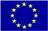  The Programme is imple-mented by the Consortium of partners led by the State Border Guard of the Republic of Latvia:  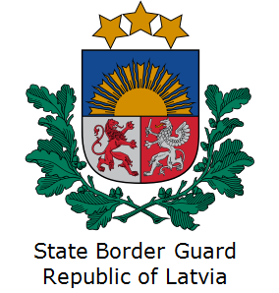 | This Programme is funded by the European Union  Delegation of the European Union to  Tajikistan  74 Adhamov street  734013 Dushanbe  Republic of Tajikistan  Phone: +992 37 221-74-07  Fax: +992 37 221-43-321  E-mail: Delegation-Tajikistan@eeas.europa.eu | The European Union is made up of 28 Member States who have decided to gradually link together their know-how, resources and destinies. Together, during a period of enlargement of 60 years, they have built a zone of stability, democracy and sustainable development whilst maintaining cultural diversity, tolerance and individual freedoms. The European Union is committed to sharing its achievements and its values with countries and peoples beyond its borders.

