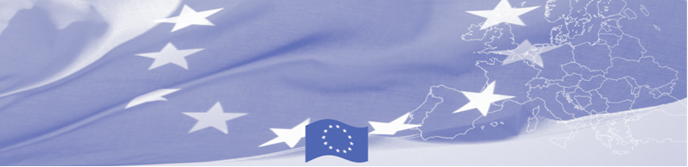
PRESS RELEASE

Food Security Committee of Tajikistan to be supported in drafting its Development strategy

Dushanbe, 21 January 2020

The EU-funded Border Management in Central Asia Programme (BOMCA) continues to provide support to border management agencies in their institutional capacity building. Taking into the account that proper agency strategy is one of the most important preconditions for progress and sustainability, a technical assistance mission starts in Dushanbe on January 21, which main goal is to assist the Food Security Committee of Tajikistan to develop the strategic development plan for its Department on the State Border and Transport.

While bilateral and multilateral meetings with management and operational staff of the Food Security Committee of Tajikistan and its Department on the State Border and Transport (further – Department) and site visits, BOMCA experts will review the state of play in the Department. Special attention will be given to legislation and regulations determining the functions and responsibilities of the Department; review of organizational structure of the Department; personnel management and available resources (personnel policy, job descriptions, duties and responsibilities of the inspectors, trainings, infrastructure, equipment and tools); regulations and control procedures; internal control system and code of ethics. Also, the order exchange of information and cooperation with other agencies and departments will be reviewed. This will be the first part of the experts’ mission to Tajikistan. Second part is scheduled for beginning of March 2020 where experts will report their findings and proposals.

Based on the findings of the mission and exchange of experience, the expert team will support Tajik partners in drafting of the Development Strategy.

The first BOMCA operations in Central Asia began in 2003 and, since then, BOMCA has strengthened the partnership between Central Asian Governments in the field of border management. The European Union allocated a sum of EUR 40, 1 million to BOMCA for the period of 2003 – 2019, out of which EUR 6, 6 million were assigned to its 9th implementation phase (2015 - 2020).

For more information, please visit web-site www.bomca-eu.org or contact Mr. Mustafo Mamadnazarov, BOMCA National Coordinator for Tajikistan – mustafo.mamadnazarov@icmpd.org

  The Programme is implemented by the Consortium of partners led by the State Border Guard of the Republic of Latvia:  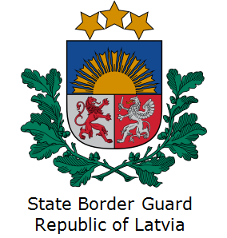 | This Programme is funded by the European Union  Delegation of the European Union to the Kyrgyz Republic  21 Erkindik Boulevard, Business Centre Orion, 5th floor  Bishkek, 720040, Kyrgyz Republic  Telephone: +996 312 26 10 00  Fax: +996 312 26 10 07  E-mail: delegation-kyrgyzstan@eeas.europa.eu  Website:http://eeas.europa.eu/delegations/kyrgyzstan  Facebook: http://www.facebook.com/eudelkg | The European Union is made up of 28 Member States who have decided to gradually link together their know-how, resources and destinies. Together, during a period of enlargement of 60 years, they have built a zone of stability, democracy and sustainable development whilst maintaining cultural diversity, tolerance and individual freedoms. The European Union is committed to sharing its achievements and its values with countries and peoples beyond its borders.

