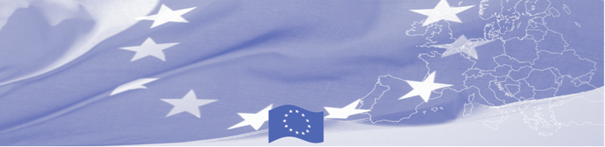
PRESS RELEASE

Regional workshop on border demarcation principles
Bishkek, 5 December 2019
From 3 to 5 December BOMCA Programme organised a three-day regional workshop on border demarcation and principles for representatives of relevant state agencies of Kyrgyzstan, Tajikistan, Uzbekistan and Turkmenistan. The activity held in Bishkek, Kyrgyzstan, brought together delegates representing Ministries of Foreign Affairs, Border Services and National Commissions on demarcation issues.
The agenda offered an opportunity for studying the Latvian experience on demarcation processes of the state border. The participants received a detailed overview of the steps, challenges and solutions identified by the Latvian colleagues while going through demarcation processes. Particular attention was given to international and national legal bases, decision-making mechanisms, functioning of the border delegate system and practical aspects of the work of the demarcation commission. Both guests and hosting experts shared national experiences and best practices of bilateral cooperation on border delimitation and demarcation, but also the challenges encountered in the process of demarcation.
The goal of this BOMCA activity was to highlight the experience, challenges and practical examples of demarcation and delimitation on Latvian borders with neighbouring countries that would give the possibility to participating officials to adapt certain useful aspects in their countries’ local context.

The first BOMCA operations in Central Asia began in 2003, and since then, BOMCA has strengthened the partnership between Central Asian Governments in the field of border management. The European Union allocated EUR 40,1 million to BOMCA for the period of 2003 – 2020; out of this amount EUR 6, 6 million was assigned to its 9th implementation phase (2015 - 2020).

For more information please contact Ms. Janna Tashieva, BOMCA Regional Communications Officer: + 996 312 902576 or janna.tashieva@icmpd.org
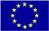  The Programme is implemented by the Consortium of partners led by the State Border Guard of the Republic of Latvia:  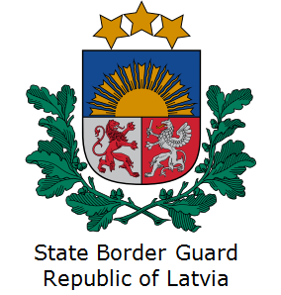 | This Programme is funded by the European Union  Delegation of the European Union to the Kyrgyz Republic  21 Erkindik Boulevard, Business Centre Orion, 5th floor  Bishkek, 720040, Kyrgyz Republic  Telephone: +996 312 26 10 00  Fax: +996 312 26 10 07  E-mail: delegation-kyrgyzstan@eeas.europa.eu  Website:http://eeas.europa.eu/delegations/kyrgyzstan  Facebook: http://www.facebook.com/eudelkg | The European Union is made up of 28 Member States who have decided to gradually link together their know-how, resources and destinies. Together, during a period of enlargement of 60 years, they have built a zone of stability, democracy and sustainable development whilst maintaining cultural diversity, tolerance and individual freedoms. The European Union is committed to sharing its achievements and its values with countries and peoples beyond its borders.

