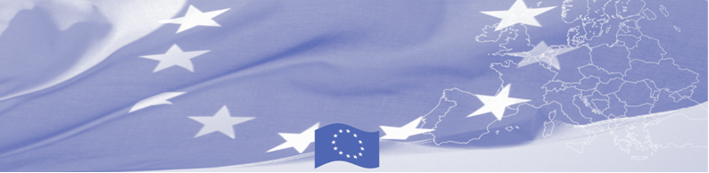
PRESS RELEASE

For release on 06 June 2016

BOMCA supports improvements in mixed migration management in Kazakhstan

Taking into account the significant number of people moving within the Central Asia borders and crossing the region in transit, the EU is continuing to offer significant support to migration management in Central Asia. Thus, a technical assistance mission on management of mixed migration flows at borders starts in Astana on June 06, 2016 within the framework of Border Management Programme in Central Asia (BOMCA). The mission envisages a mixture of a workshop and round-table discussions between the European Union experts from the State Border Guard of Latvia and Immigration and Borders Service of Portugal, with close collaboration with OSCE Programme office in Astana and International Organization for Migration on the one hand, and Kazakhstan national experts working on the issue of trafficking in human beings and readmission, on the other hand. Local counterparts will be represented by the Border Service of the Committee of National Security, and Department Migration Police of the Ministry of Interior of the Republic of Kazakhstan.

The key objective of the technical assistance mission is to discuss national legislation in line with international practices dealing with vulnerable groups of migrants passing through borders and explore legislation of the EU countries in relation to working with such migrant groups. Participants will discuss good practices from the EU MSs and Kazakhstan in countering trafficking in human beings and smuggling of persons at the borders, as well as exchange their experience and learn about EU best practices in readmission.

Based on discussions and exchange of views with the national experts, the EU, OSCE and IOM experts will develop recommendations on amendments of specific pieces of the national legislation related to management of vulnerable migrant groups at borders and readmission in line with international best practices.

First BOMCA operations began in Central Asia in 2003, and since then, BOMCA has strengthened partnership of the Central Asia Governments in the field of border management. The European Union allocated a sum of EUR 33.6 million to BOMCA for the period of 2003 – 2014 and almost EUR 5 million for its 9th implementation phase (2015 - 2018).

For more information please contact BOMCA in Kazakhstan – +7 701532 0264 or amir.yelchibekov@icmpd.org

  The Programme is imple-mented by the Consortium of partners led by the State Border Guard of the Republic of Latvia:  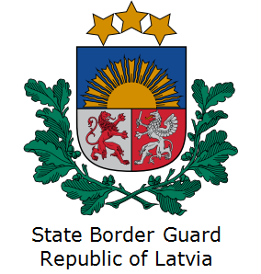 | This Programme is funded by the European Union  Delegation of the European Union to Kazakhstan  62, Kosmonavtov street, 4th floor  Astana, 010000, Republic of Kazakhstan  Telephone: + 7 7172 97 10 40, 97-11-48  Fax: + 7 7172 97 95 63  E-mail: Delegation-Kazakhstan@eeas.europa.eu  Website:http://eeas.europa.eu/delegations/Kazakhstan  Website: https://www.bomca-eu.org | The European Union is made up of 28 Member States who have decided to gradually link together their know-how, resources and destinies. Together, during a period of enlargement of 60 years, they have built a zone of stability, democracy and sustainable development whilst maintaining cultural diversity, tolerance and individual freedoms. The European Union is committed to sharing its achievements and its values with countries and peoples beyond its borders.

