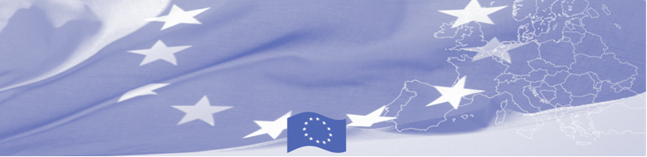
PRESS RELEASE

9th phase of BOMCA is extended for 4, 5-months period

The current 9th phase of the EU-funded Border Management in Central Asia Programme (BOMCA) will be extended until April 30, 2020 - this decision was made by the European Commission.

This no-cost extension will provide time for the follow-up on the achievements through the current programme phase implementation. Jointly with the national counterparts, the project team will analyse the utilisation of the recommendations, guidelines and draft documents elaborated by the European experts. By the end of April 2020, the programme will strengthen the results through implementation of the activities in the following areas: strategic planning at border security institutions in Central Asia, enhancing risk analysis capabilities, providing EU experiences in border delimitation and demarcation, support in development of institutional strategies.

In the extension period, particular attention will be paid to smooth closing of BOMCA-9 and transition to the next, 10th phase of the Programme, which is expected to be launched in spring 2020.

The first BOMCA operations in Central Asia began in 2003, and since then, BOMCA has strengthened the partnership between Central Asian Governments in the field of border management. The European Union allocated EUR 40,1 million to BOMCA for the period of 2003 – 2020; out of this amount EUR 6, 6 million was assigned to its 9th implementation phase (2015 - 2020).

For more information please contact Ms. Janna Tashieva, BOMCA Regional Communications Officer: + 996 312 902576 or janna.tashieva@icmpd.org

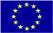  The Programme is implemented by the Consortium of partners led by the State Border Guard of the Republic of Latvia:  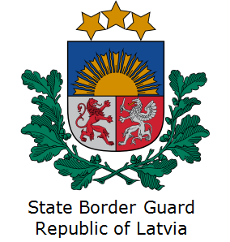 | This Programme is funded by the European Union  Delegation of the European Union to the Kyrgyz Republic  21 Erkindik Boulevard, Business Centre Orion, 5th floor  Bishkek, 720040, Kyrgyz Republic  Telephone: +996 312 26 10 00  Fax: +996 312 26 10 07  E-mail: delegation-kyrgyzstan@eeas.europa.eu  Website:http://eeas.europa.eu/delegations/kyrgyzstan  Facebook: http://www.facebook.com/eudelkg | The European Union is made up of 28 Member States who have decided to gradually link together their know-how, resources and destinies. Together, during a period of enlargement of 60 years, they have built a zone of stability, democracy and sustainable development whilst maintaining cultural diversity, tolerance and individual freedoms. The European Union is committed to sharing its achievements and its values with countries and peoples beyond its borders.

