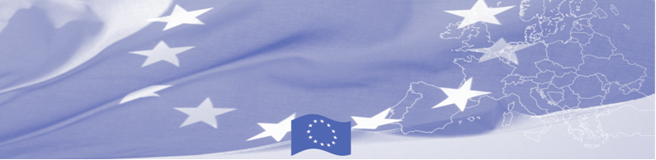
PRESS-RELEASE

Border agencies of Central Asia enhancing inter-agency cooperation in the area joint strategic management

Ashgabat, 12 November 2019

On 12-14 November 2019, a regional workshop on inter-agency cooperation in the area of joint strategic management is being held in Ashgabat, Turkmenistan within the framework of EU-funded Border Management in Central Asia Programme. The workshop gathered 20 representatives of border and customs agencies from Kazakhstan, Kyrgyzstan, Turkmenistan and Uzbekistan and is facilitated by experts from the State Border Guard of Latvia, State Revenue Service of Latvia and Estonian Academy of Internal Security. The main aim of the workshop is to strengthen inter-agency cooperation by developing practical recommendations on joint strategic management in border agencies.

During the workshop national expert will present their countries and agencies strategic development systems and IBM related strategies – overall structure, legal base, main directions, implementation process. European experts in their turn will present best practices of EU Member States in developing the inter-agency and international cooperation at strategic level. Based on mutual discussions, directions for further improvement will be identified and recommendations will be developed by the expert group on strengthening the inter-agency cooperation among border agencies based of joint strategic management; on IBM development on strategic level.

The first BOMCA operations in Central Asia began in 2003 and, since then, BOMCA has strengthened the partnership between Central Asian Governments in the field of border management. The European Union allocated a sum of EUR 40, 1 million to BOMCA for the period of 2003 – 2020, out of which EUR 6,6 million were assigned to its 9th implementation phase (2015 - 2020).

For more information please contact Mr. Rustam Berdiyev, BOMCA National Coordinator in Turkmenistan, + 993 65 555435 or rustam.berdiyev.bomca@gmail.com

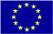  The Programme is imple-mented by the Consortium of partners led by the State Border Guard of the Republic of Latvia:  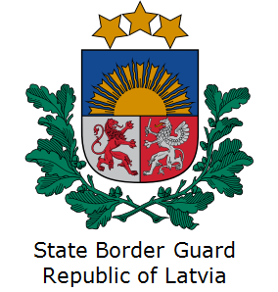 | This Programme is funded by the European Union  Delegation of the European Union to Turkmenistan  Pervy Proezd Myati Kosaeva, 8, Ashgabat. Tel: +993-12-349752  E-mail: delegation-turkmenistan@eeas.europa.eu | The European Union is made up of 28 Member States who have decided to gradually link together their know-how, resources and destinies. Together, during a period of enlargement of 60 years, they have built a zone of stability, democracy and sustainable development whilst maintaining cultural diversity, tolerance and individual freedoms. The European Union is committed to sharing its achievements and its values with countries and peoples beyond its borders.

