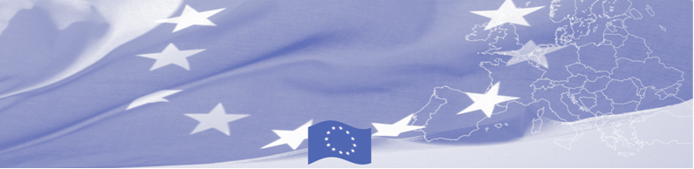
PRESS RELEASE

Yearly meeting of Border and Customs Training institutions of Central Asia takes place in Tashkent

Tashkent, 15 October 2019

On October 15, 2019 a Regional Workshop for border guard and customs training institutions of Central Asian countries started its work in Tashkent within the framework of the Border Management in Central Asia (BOMCA) programme, financed by the European Union. The activity gathers delegates from all five Central Asian countries to discuss joint approach and continuous cooperation of training institutions towards the development of the unique, harmonised, and efficient training system for border guards and customs officers in the Central Asian region. The workshop is facilitated by the experts from the State Border Guard of Latvia and Riga Technical University.
During the workshop national experts will present and discuss current training systems in CA countries, as well as innovative approaches and methodological tools. The professionals will identify existing needs, gaps and best practices in training processes. The meeting will build upon results of the previous years and the experts jointly with the CA representatives will review the progress of implementation of the action points agreed in 2016, 2017 and 2018 as well as define further plans for next phase of BOMCA which will begin in 2020.
The idea of creating a joint platform of training institutions was born in 2012 and further developed and implemented with BOMCA support. It is a voluntary association of training institutions linked to each other by a joint scientific research, development of training curricula, lectures and professional training courses, and unification of education and training processes. The members of the Consortia strive for joint capacity building and institutional development activities, and unique development of training curricula and research activities.

The first BOMCA operations in Central Asia began in 2003 and, since then, BOMCA has strengthened the partnership between Central Asian Governments and Agencies in the field of border management. The European Union has allocated a sum of EUR 40.1 million to BOMCA for the period of 2003 – 2019, out of which more than EUR 6.6 million were assigned to its 9th implementation phase (2015 - 2019).

For more information, please visit web-site www.bomca-eu.org or contact Ms. Janna Tashieva, BOMCA National Coordinator for Kyrgyzstan – janna.tashieva@icmpd.org

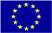  The Programme is implemented by the Consortium of partners led by the State Border Guard of the Republic of Latvia:  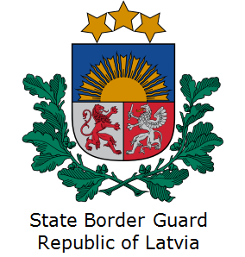 | This Programme is funded by the European Union  Delegation of the European Union to the Kyrgyz Republic  21 Erkindik Boulevard, Business Centre Orion, 5th floor  Bishkek, 720040, Kyrgyz Republic  Telephone: +996 312 26 10 00  Fax: +996 312 26 10 07  E-mail: delegation-kyrgyzstan@eeas.europa.eu  Website:http://eeas.europa.eu/delegations/kyrgyzstan  Facebook: http://www.facebook.com/eudelkg | The European Union is made up of 28 Member States who have decided to gradually link together their know-how, resources and destinies. Together, during a period of enlargement of 60 years, they have built a zone of stability, democracy and sustainable development whilst maintaining cultural diversity, tolerance and individual freedoms. The European Union is committed to sharing its achievements and its values with countries and peoples beyond its borders.

