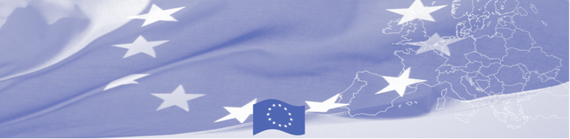
PRESS RELEASE

BOMCA and its national partners wrapping up the year and making plans for the future

EU-funded Border Management in Central Asia Programme BOMCA Programme launched a new round of National Steering Group meetings. The series of five meetings in Central Asia countries began in Ashgabat (Turkmenistan) on September 13, continues in Dushanbe (Tajikistan) on 23 September, Tashkent (Uzbekistan) on 26 September, Nur – Sultan (Kazakhstan) on 30 September and will terminate in Bishkek (Kyrgyzstan) on October 03, 2019.
During the meetings, BOMCA together with its key partners from the beneficiary agencies, as well as EU representatives jointly asses the work done during the previous year and discuss planned activities for the rest of the programme duration. Beneficiaries provide feedback of the status of recommendations, developed by BOMCA in 2016, 2017 and 2018 and inform which recommendations have been adopted into practice and which could be considered as potentially useful in the future. Partners are also given the possibility to share their opinions and ideas that came out of the participation in the BOMCA activities so far as well as provide their recommendations for the successful implementation of remaining activities planned for 2019.
The National Steering Group Meetings continue to serve a basis for monitoring progress towards project goals and a reference point for efficiency of co-operation and partnerships with the beneficiaries during the implementation phase.

The first BOMCA operations in Central Asia began in 2003 and, since then, BOMCA has strengthened the partnership between Central Asian Governments in the field of border management. The European Union allocated a sum of EUR 40, 1 million to BOMCA for the period of 2003 – 2019, out of which EUR 6, 6 million were assigned to its 9th implementation phase (2015 - 2019). In total 205 activities were implemented by the end of August 2019 in Central Asia countries with the engagement of over 3 000 state officials of beneficiary agencies and provided equipment to 4 CA countries for over 330 000 EUR.

For more information please contact Ms. Janna Tashieva, BOMCA National Coordinator in Kyrgyzstan – + 996 312 902576 or janna.tashieva@icmpd.org
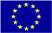  The Programme is implemented by the Consortium of partners led by the State Border Guard of the Republic of Latvia:  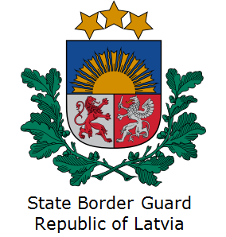 | This Programme is funded by the European Union  Delegation of the European Union to the Kyrgyz Republic  21 Erkindik Boulevard, Business Centre Orion, 5th floor  Bishkek, 720040, Kyrgyz Republic  Telephone: +996 312 26 10 00  Fax: +996 312 26 10 07  E-mail: delegation-kyrgyzstan@eeas.europa.eu  Website:http://eeas.europa.eu/delegations/kyrgyzstan  Facebook: http://www.facebook.com/eudelkg | The European Union is made up of 28 Member States who have decided to gradually link together their know-how, resources and destinies. Together, during a period of enlargement of 60 years, they have built a zone of stability, democracy and sustainable development whilst maintaining cultural diversity, tolerance and individual freedoms. The European Union is committed to sharing its achievements and its values with countries and peoples beyond its borders.

