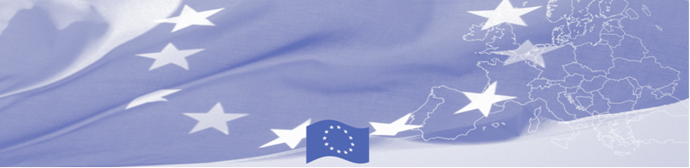
PRESS RELEASE

Analysis of the system of education and retraining
of border guards and customs officers in Tajikistan
Dushanbe, June 17, 2019
On June 17-19 in Dushanbe, experts of the EU-funded Border Management Program in Central Asia (BOMCA) analyze the current state and needs of the training and retraining system of border guards and customs officers in Tajikistan. Representatives of Riga Technical University and State Border Guard of Latvia hold a series of meetings and consultations with the leadership and key departments of the Customs Service, Border Troops, as well as educational institutions - Higher Border Institute, Poytaht Training Center of Border Troops, OSCE Border College, Tajik State University of Commerce, Financial and Economic Institute of Tajikistan, Institute of Advanced Studies of the Customs Service.
Among other issues, the expert group studies such issues as curriculum development and its content; teacher professional development; e-learning system, interactive teaching methods and use of information technologies; research work and participation in national and international projects; international cooperation and use of international experience. Current challenges in educational and retraining system are being considered as well as necessary adequate measures to improve its quality and effectiveness. At the end of the mission, experts will provide recommendations on strengthening institutional capacity in the field of HR policy and improvement of the quality of training in border and customs agencies and relevant educational institutions.
The wider general task of this advisory mission is to assist in the implementation of the objectives of the National Border Management Strategy of the Republic of Tajikistan, in particular of its the section related to the training of personnel of border agencies.
The first BOMCA operations in Central Asia began in 2003 and, since then, BOMCA has strengthened the partnership between Central Asian Governments in the field of border management. The European Union allocated a sum of EUR 40, 1 million to BOMCA for the period of 2003 – 2019, out of which EUR 6, 6 million were assigned to its 9th implementation phase (2015 - 2019).

For more information, please visit web-site www.bomca-eu.org or contact Mr. Mustafo Mamadnazarov, BOMCA National Coordinator for Tajikistan – mustafo.mamadnazarov@icmpd.org
  The Programme is imple-mented by the Consortium of partners led by the State Border Guard of the Republic of Latvia:  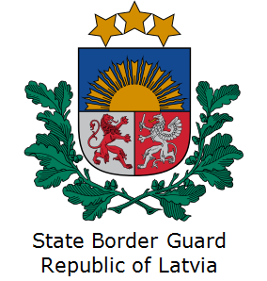 | This Programme is funded by the European Union  Delegation of the European Union to  Tajikistan  74 Adhamov street, 734013 Dushanbe  Republic of Tajikistan  Phone: +992 37 221-74-07  Fax: +992 37 221-43-321  E-mail: Delegation-Tajikistan@eeas.europa.eu | The European Union is made up of 28 Member States who have decided to gradually link together their know-how, resources and destinies. Together, during a period of enlargement of 60 years, they have built a zone of stability, democracy and sustainable development whilst maintaining cultural diversity, tolerance and individual freedoms. The European Union is committed to sharing its achievements and its values with countries and peoples beyond its borders.

