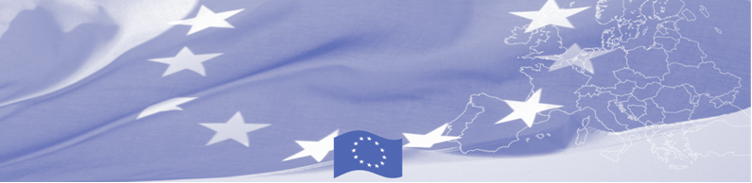
PRESS RELEASE

BOMCA provides consultative support to
Kyrgyz Customs in the field of Implementation of TFA Action Plan
(Trade Facilitation Agreement)

Bishkek, May 20, 2019

Technical consultative mission of the Border Management Program in Central Asia (BOMCA), funded by the European Union, is being held in Kyrgyzstan on May 20-23. Experts of the Customs Department of the Ministry of Finance of Lithuania hold a number of consultations with Kyrgyz customs regarding the implementation of TFA Action Plan, namely, its articles on studying international experience and analyzing current legislation on border cooperation , customs cooperation and information exchange.
Together with their Kyrgyz colleagues, experts will analyze the current situation regarding cooperation and coordination between the customs authorities, study international agreements and provide international experience in this field. An analysis of the regulatory framework will be done and, if necessary, proposals will be made to amend the relevant regulatory and legal acts concerning the exchange of customs information in line with TFA provisions.
The first BOMCA operations in Central Asia began in 2003 and, since then, BOMCA has strengthened the partnership between Central Asian Governments in the field of border management. The European Union allocated a sum of EUR 40, 1 million to BOMCA for the period of 2003 – 2019, out of which EUR 6, 6 million were assigned to its 9th implementation phase (2015 - 2019).

For more information please contact Ms. Janna Tashieva, BOMCA National Coordinator in Kyrgyzstan – + 996 312 902576 or janna.tashieva@icmpd.org

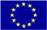  The Programme is implemented by the Consortium of partners led by the State Border Guard of the Republic of Latvia:  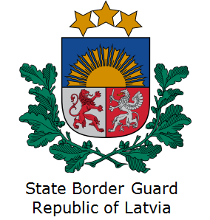 | This Programme is funded by the European Union  Delegation of the European Union to the Kyrgyz Republic  21 Erkindik Boulevard, Business Centre Orion, 5th floor  Bishkek, 720040, Kyrgyz Republic  Telephone: +996 312 26 10 00  Fax: +996 312 26 10 07  E-mail: delegation-kyrgyzstan@eeas.europa.eu  Website:http://eeas.europa.eu/delegations/kyrgyzstan  Facebook: http://www.facebook.com/eudelkg | The European Union is made up of 28 Member States who have decided to gradually link together their know-how, resources and destinies. Together, during a period of enlargement of 60 years, they have built a zone of stability, democracy and sustainable development whilst maintaining cultural diversity, tolerance and individual freedoms. The European Union is committed to sharing its achievements and its values with countries and peoples beyond its borders.

