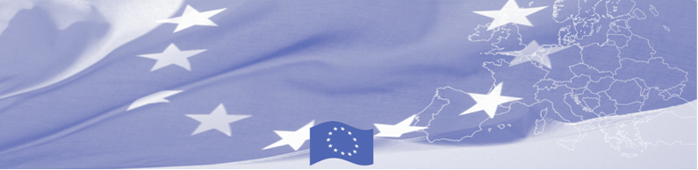
Press Release

Workshop on Prevention and Detection of Illegal Trafficking of Goods and Means of Transport

Aktau, Kuryk sea port, May 14 2019

On May 14 -16 a three-day bilateral workshop is being held in Aktau, Kazakhstan aimed to improve the practical skills of customs authorities of Kazakhstan and Turkmenistan in the area of prevention and detection of illegal trafficking of goods and means of transport. The event is organized by EU-funded Border Management in Central Asia Programme (BOMCA) in cooperation with United Nations Office on Drugs and Crime (UNODC). The workshop is facilitated by the experts of Customs Department under the Ministry of Finance of Lithiania.

The customs and border guards of Kazakhstan and Turkmenistan will get familiar with the Lithuanian experience in assessing risk factors when selecting ships and containers for customs inspection. Participants will learn about the types of sea containers, methods of their verification and compliance with safety regulations during the inspection. Also, European experts will share experience on the “Rip-off” method of smuggling narcotic drugs in containers. During practical exercise in Aktau sea port typical places for caches in ships and containers will be demonstrated based on European experience.

The first BOMCA operations in Central Asia began in 2003 and, since then, BOMCA has strengthened the partnership between Central Asian Governments in the field of border management. The European Union allocated a sum of EUR 40, 1 million to BOMCA for the period of 2003 – 2019, out of which EUR 6, 6 million were assigned to its 9th implementation phase (2015 - 2019).

For more information please contact Mr. Amir Yelchibekov, BOMCA National Coordinator in Kazakhstan – +7 701 532 02 64 or amir.yelchibekov@icmpd.org

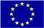  The Programme is implemented by the Consortium of partners led by the State Border Guard of the Republic of Latvia:  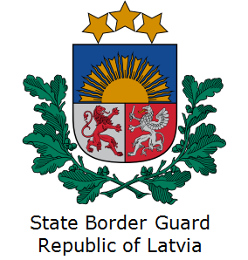 | This Programme is funded by the European Union  Delegation of the European Union to the Republic of Kazakhstan, 010000, Astana, Cosmonauts street 62, 4 floor  Telephone: + 7 7172 97 10 40  Fax: + 7 7172 97 95 63  e-mail Delegation-Kazakhstan @eeas.europa.eu  web.site:http://eeas.europa.eu/delegations /kazakhstan | The European Union is made up of 28 Member States who have decided to gradually link together their know-how, resources and destinies. Together, during a period of enlargement of 60 years, they have built a zone of stability, democracy and sustainable development whilst maintaining cultural diversity, tolerance and individual freedoms. The European Union is committed to sharing its achievements and its values with countries and peoples beyond its borders.

