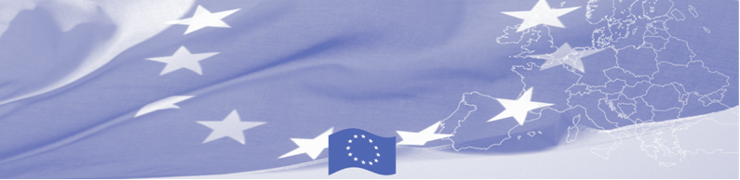
PRESS RELEASE

Regional workshop on EU standards on identification, detention and return of irregular migrants

Tashkent, 16 April 2019

Regional workshop on EU standards on identification, detention and return of irregular migrants starts in Tashkent on April 16, 2019 organized by EU-funded Border Management Programme in Central Asia (BOMCA) in cooperation with International Organization for Migration (IOM). The event envisages a mixture of a workshop and round-table discussions between the international experts on the one hand, and CA countries national experts working on the issue of identification, detention and return of irregular migrants, on the other hand.

Main goal of the event is to introduce the best international and European practices of detention, accommodation and return of irregular migrants. CA participants will report on national procedures in the area of return, detention and readmission, European experts in their turn will introduce international and European standards and approaches. Special attention will be paid to cooperation between institutions in the fight against irregular migration at the state border and within the country, as well as to standards of detention procedure. Practical examples of identification of migrants with irregular status, including vulnerable groups will be discussed and analyzed.

Based on discussions and exchange of views with the national experts, the EU experts will develop recommendations to specific pieces of the national legislation in line with international best practices.

The first BOMCA operations in Central Asia began in 2003 and, since then, BOMCA has strengthened the partnership between Central Asian Governments in the field of border management. The European Union allocated a sum of EUR 40, 1 million to BOMCA for the period of 2003 – 2019, out of which EUR 6, 6 million were assigned to its 9th implementation phase (2015 - 2019).

For more information please contact Ms. Janna Tashieva, BOMCA National Coordinator in Kyrgyzstan – + 996 312 902576 or janna.tashieva@icmpd.org
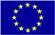  The Programme is implemented by the Consortium of partners led by the State Border Guard of the Republic of Latvia:  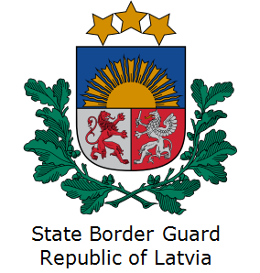 | This Programme is funded by the European Union  Delegation of the European Union to the Kyrgyz Republic  21 Erkindik Boulevard, Business Centre Orion, 5th floor  Bishkek, 720040, Kyrgyz Republic  Telephone: +996 312 26 10 00  Fax: +996 312 26 10 07  E-mail: delegation-kyrgyzstan@eeas.europa.eu  Website:http://eeas.europa.eu/delegations/kyrgyzstan  Facebook: http://www.facebook.com/eudelkg | The European Union is made up of 28 Member States who have decided to gradually link together their know-how, resources and destinies. Together, during a period of enlargement of 60 years, they have built a zone of stability, democracy and sustainable development whilst maintaining cultural diversity, tolerance and individual freedoms. The European Union is committed to sharing its achievements and its values with countries and peoples beyond its borders.

