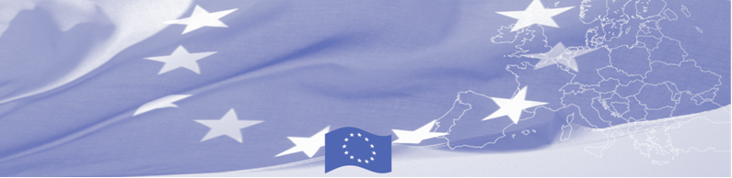
PRESS RELEASE

Online educational systems are being introduced to border guarding and customs educational institutions of Kazakhstan

Almaty, 18 March, 2019

On 18- 20 March 2019 a workshop on online education for border guard and customs training institutions of Kazakhstan is to be held in Central Asian Regional Information and Coordination Center for Combating the Illicit Drug Trafficking (CARICC) in the framework of the Border Management in Central Asia (BOMCA) programme, financed by the European Union. The activity gathers representatives from higher educational institutions forming border guards and customs officers as well as training centres of Border and Customs services and is facilitated by the experts from the Latvian State Revenue Service.

During the workshop participants will present and discuss current available electronic educational systems for border guards and customs officers in Kazakhstan, identify existing needs, gaps and best practices in training processes. European Union experts will introduce European educational online programs, including standards, opportunities, information of challenges and potential solutions, present related tools, instruments and country examples. Based on workshop’s findings, the expert team will elaborate and share recommendation on further development of electronic educational programs of border guarding and customs training institutions in Kazakhstan.

The first BOMCA operations in Central Asia began in 2003 and, since then, BOMCA has strengthened the partnership between Central Asian Governments in the field of border management. The European Union allocated a sum of EUR 40, 1 million to BOMCA for the period of 2003 – 2019, out of which EUR 6, 6 million were assigned to its 9th implementation phase (2015 - 2019).

For more information please contact Mr. Amir Yelchibekov, BOMCA National Coordinator in Kazakhstan – +7 701 532 02 64 or amir.yelchibekov@icmpd.org

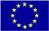  The Programme is implemented by the Consortium of partners led by the State Border Guard of the Republic of Latvia:  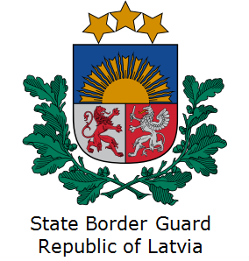 | This Programme is funded by the European Union  Delegation of the European Union to the  Republic of Kazakhstan, 010000, Astana, Cosmonauts street 62, 4 floor  Telephone: + 7 7172 97 10 40  Fax: + 7 7172 97 95 63  e-mail Delegation-Kazakhstan @eeas.europa.eu  web.site:http://eeas.europa.eu/delegations /kazakhstan | The European Union is made up of 28 Member States who have decided to gradually link together their know-how, resources and destinies. Together, during a period of enlargement of 60 years, they have built a zone of stability, democracy and sustainable development whilst maintaining cultural diversity, tolerance and individual freedoms. The European Union is committed to sharing its achievements and its values with countries and peoples beyond its borders.

