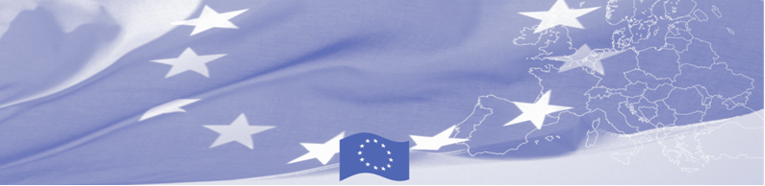
PRESS RELEASE

Strengthening interagency cooperation for effective contingency planning

Almaty, 12 March 2019

On March 12-14 in Almaty workshop on contingency planning on border checkpoints was held, gathering representatives of different state agencies of Kazakhstan– Border Service, State Revenue Committee, Emergency Situation Committee, Border Guards Academy and Ministry of Agriculture. The workshop is being facilitated by experts of EU-funded Border Management in Central Asia Programme (BOMCA) and UN Refugee Agency (UNHCR).
Expert team together with national counterparts reviewed existing framework of respond to emergency situations, consisting of constitutional and legislative bases and related operational framework, including organisational structure of the contingency planning and its operational requirements. During the seminar, resources and operational procedures of a standard border checkpoint were presented to participants and, based on Latvian experience, an example of an advanced coordination mechanism, ensuring appropriate and effective cooperative response measures was shared by expert team.
During the practical exercise, a draft of joint instructions on interagency operating procedures was created specifying roles, responsibilities and working methods during different kinds of emergency situations at the checkpoint, including also mass inflow of migrants.
The wider objective of this BOMCA activity is to assist in establishing/strengthening effective mechanisms to facilitate prompt exchange of information between institutions involved in border security.
The first BOMCA operations in Central Asia began in 2003 and, since then, BOMCA has strengthened the partnership between Central Asian Governments in the field of border management. The European Union allocated a sum of EUR 40, 1 million to BOMCA for the period of 2003 – 2019, out of which EUR 6, 6 million were assigned to its 9th implementation phase (2015 - 2019).

For more information please contact Mr. Amir Yelchibekov, BOMCA National Coordinator in Kazakhstan – +7 701 532 02 64 or amir.yelchibekov@icmpd.org

  The Programme is imple-mented by the Consortium of partners led by the State Border Guard of the Republic of Latvia:  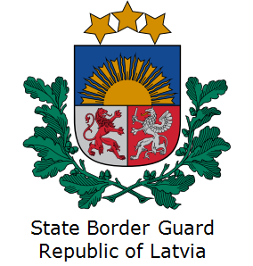 | This Programme is funded by the European Union  Delegation of the European Union to  Kazakhstan  62, Kosmonavtov street, 4th floor  Astana, 010000, Republic of Kazakhstan  Telephone: + 7 7172 97 45 40, 97-11-48  Fax: + 7 7172 97 95 63  E-mail: Delegation-Kazakhstan@eeas.europa.eu  Website:http://eeas.europa.eu/delegations/Kazakhstan  Website: https://www.bomca-eu.org | The European Union is made up of 28 Member States who have decided to gradually link together their know-how, resources and destinies. Together, during a period of enlargement of 60 years, they have built a zone of stability, democracy and sustainable development whilst maintaining cultural diversity, tolerance and individual freedoms. The European Union is committed to sharing its achievements and its values with countries and peoples beyond its borders.

