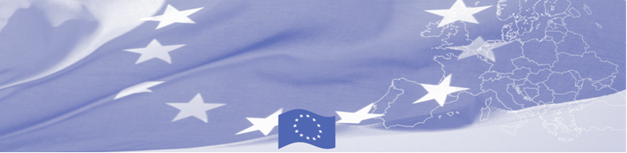
PRESS RELEASE

European anti-corruption experience is presented to Central Asian border agencies

Dushanbe, February 12, 2017

On February 12-14, a group of European experts is visiting Dushanbe to hold a workshop for Tajik, Turkmen and Uzbek border agencies on law enforcement ethics, professional conduct and the fight against corruption. The event is organized by the Border Management Programme in Central Asia Programme (BOMCA), funded by the European Union. The invited experts together with the representatives of the Border management agencies will discuss the system of fighting against corruption, the standards of law enforcement ethics and professional conduct of staff in border agencies and countries experience in this direction. This activity of the BOMCA Program is aimed at improving the effectiveness of the border management system in Central Asia by introducing anti-corruption measures in accordance with international law enforcement standards and norms.

European experts will present European practices in combating corruption in European border agencies, including modern methods and systems for monitoring ethical and professional conduct in border agencies (the code of ethics and its principles), will talk about relevant tools and mechanisms, provide and analyse specific examples. National experts, in their turn, will share their views on fighting corruption and practical experience in the implementation of international law enforcement standards and norms in the State bodies.

The first BOMCA operations in Central Asia began in 2003 and, since then, BOMCA has strengthened the partnership between Central Asian Governments in the field of border management. The European Union allocated a sum of EUR 40, 1 million to BOMCA for the period of 2003 – 2019, out of which EUR 6, 6 million were assigned to its 9th implementation phase (2015 - 2019).

For more information please contact Mr. Mustafo Mamadnazarov, BOMCA National Coordinator in Tajikistan – mustafo.mamadnazarov@icmpd.org

  The Programme is imple-mented by the Consortium of partners led by the State Border Guard of the Republic of Latvia:  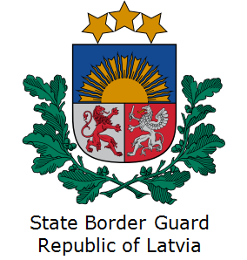 | This Programme is funded by the European Union  Delegation of the European Union to  Tajikistan  74 Adhamov street, 734013 Dushanbe  Republic of Tajikistan  Phone: +992 37 221-74-07  Fax: +992 37 221-43-321  E-mail: Delegation-Tajikistan@eeas.europa.eu | The European Union is made up of 28 Member States who have decided to gradually link together their know-how, resources and destinies. Together, during a period of enlargement of 60 years, they have built a zone of stability, democracy and sustainable development whilst maintaining cultural diversity, tolerance and individual freedoms. The European Union is committed to sharing its achievements and its values with countries and peoples beyond its borders.

