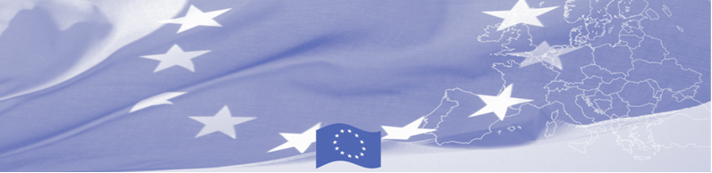
PRESS RELEASE

International practice on criminal investigation in risk management
is introduced to Kazakh Customs officers

Astana, January 29, 2019

EU is continuing to offer significant support to trade facilitation activities in Central Asia. Thus, a technical assistance mission on risk management in customs control starts in Astana on January 29, 2019 within the framework of Border Management Programme in Central Asia (BOMCA), funded by the European Union. International and local experts gather together to discuss criminal investigation in customs control and how does Kazakh Customs apply it on practice. This BOMCA activity aims to provide the technical assistance in the area of the development and improvement of risk management systems in CA countries.

By reviewing and consolidating various existing national and international regulations, national and European experts exchange experience and practices on criminal investigation and its principles, interconnectivity of e-intelligence with risk management. Integration of criminal investigation into risk analysis system will promote a more harmonised approach to customs control and create a more transparent, up-to-date and effective system of import controls, allowing more coherence in and integration of the different control mechanisms in place

The first BOMCA operations in Central Asia began in 2003 and, since then, BOMCA has strengthened the partnership between Central Asian Governments in the field of border management. The European Union allocated a sum of EUR 40, 1 million to BOMCA for the period of 2003 – 2019, out of which EUR 6, 6 million were assigned to its 9th implementation phase (2015 - 2019).

For more information please please visit web-site www.bomca-eu.org or contact BOMCA in Kazakhstan – +7 701 532 02 64 or amir.yelchibekov@icmpd.org

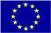  The Programme is imple-mented by the Consortium of partners led by the State Border Guard of the Republic of Latvia:  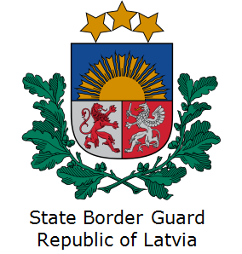 | This Programme is funded by the European Union  Delegation of the European Union to  Kazakhstan  62, Kosmonavtov street, 4th floor  Astana, 010000, Republic of Kazakhstan  Telephone: + 7 7172 97 45 40, 97-11-48  Fax: + 7 7172 97 95 63  E-mail: Delegation-Kazakhstan@eeas.europa.eu  Website:http://eeas.europa.eu/delegations/Kazakhstan  Website: https://www.bomca-eu.org | The European Union is made up of 28 Member States who have decided to gradually link together their know-how, resources and destinies. Together, during a period of enlargement of 60 years, they have built a zone of stability, democracy and sustainable development whilst maintaining cultural diversity, tolerance and individual freedoms. The European Union is committed to sharing its achievements and its values with countries and peoples beyond its borders.

