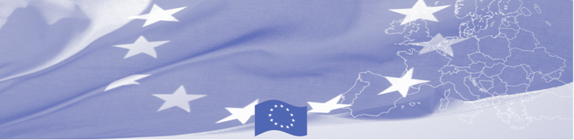
PRESS RELEASE

Central Asian border guard training institutions
exchanging best practices in teaching methodology

Dushanbe, 18 December 2018

On December 18 - 20, 2018 the group of trainers of Kazakh Border Guard Academy is visiting Dushanbe for sharing their institutional experience and best practices in teaching methodology with their Kyrgyz and Tajik colleagues. The activity is organized within framework of Component 1 “Institutional development of Border Agencies” of EU-funded Border Management in Central Asia Programme (BOMCA) Work Plan for 2018 - 2019.

BOMCA programme historically has been attaching a great importance to an effective institutional partnership and dynamic collaborative process between CA and EU training institutions of border security-related agencies. To this effect, CA Customs and BG training institutions Consortia were launched by initiative of BOMCA Programme in 2011 as a forum for the joint approach and cooperation towards the development of the harmonized and efficient training system for Central Asia Customs and BG staff.

Based on jointly defined during Consortium meetings list of educational topics, BOMCA supports exchange of trainers between BG and Customs training institutions. A pilot one was conducted in Dushanbe between 29 May - 1 June 2017, where trainers from the customs training centers of Kyrgyzstan and Uzbekistan facilitated training of trainers for their Tajik colleagues on the issues of radiation control and dual-use goods. As a next step in exchange of trainers’ experience, the Higher Military Customs Institute of the Republic of Uzbekistan demonstrated best practices in X-ray image analysis by hosting between 13 - 15 June, 2017 a regional training for trainers and customs officers from Central Asia. In 2018 the exchange of trainers was successfully continued by Kazakhstan - on February 13 - 15 trainers from Border Guard Academy of Kazakhstan came to Bishkek, Kyrgyzstan and conduct ToT for their Kyrgyz colleagues - 15 teachers of BG Training center and Military Institute were trained on teaching methodology on the topic of traveller’s identification and profiling.

The first BOMCA operations in Central Asia began in 2003 and, since then, BOMCA has strengthened the partnership between Central Asian Governments in the field of border management. The European Union allocated a sum of EUR 40, 1 million to BOMCA for the period of 2003 – 2019, out of which EUR 6, 6 million were assigned to its 9th implementation phase (2015 - 2019).

For more information please contact Ms. Janna Tashieva, BOMCA National Coordinator in Kyrgyzstan – + 996 312 902576 or janna.tashieva@icmpd.org

  The Programme is imple-mented by the Consortium of partners led by the State Border Guard of the Republic of Latvia:  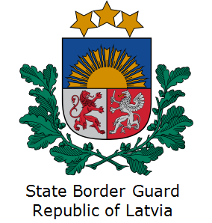 | This Programme is funded by the European Union  Delegation of the European Union to the Kyrgyz Republic  21 Erkindik Boulevard, Business Centre Orion, 5th floor  Bishkek, 720040, Kyrgyz Republic  Telephone: +996 312 26 10 00  Fax: +996 312 26 10 07  E-mail: delegation-kyrgyzstan@eeas.europa.eu  Website:http://eeas.europa.eu/delegations/  kyrgyzstan  Facebook:http://www.facebook.com/eudelkg | The European Union is made up of 28 Member States who have decided to gradually link together their know-how, resources and destinies. Together, during a period of enlargement of 60 years, they have built a zone of stability, democracy and sustainable development whilst maintaining cultural diversity, tolerance and individual freedoms. The European Union is committed to sharing its achievements and its values with countries and peoples beyond its borders.

