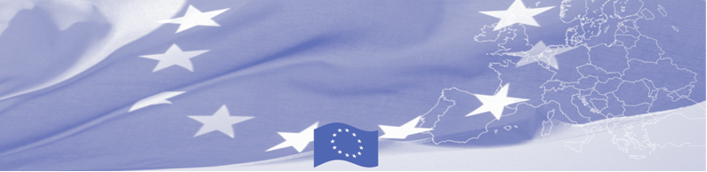
PRESS RELEASE

Strengthening interagency cooperation for effective contingency planning

Bishkek, 16 October 2018

Bishkek hosts a workshop on interaction of state agencies involved in border control. Representatives of Border and Customs Services, Ministry of Agriculture and State Inspection of Veterinary and Phytosanitary Security discuss the issues of cooperation on border check points and assess international experience in this direction. The workshop is being facilitated by the programme experts of Border Management in Central Asia Programme, funded by the European Union.

Taking into the account that interagency cooperation and timely exchange of information at intra-, interagency and international levels are one of main constituents of effective implementation of Integrated Border Management, the workshop will be mainly focused on information exchange, analysing and structuring the data, information flows management within an agency and between the agencies and countries. Based on Latvia experience, an advanced example of effective cooperation between the agencies and States will be introduced to participants.

The first BOMCA operations in Central Asia began in 2003 and, since then, BOMCA has strengthened the partnership between Central Asian Governments in the field of border management. The European Union allocated a sum of EUR 40, 1 million to BOMCA for the period of 2003 – 2019, out of which EUR 6, 6 million were assigned to its 9th implementation phase (2015 - 2019).

For more information, please visit web-site www.bomca-eu.org or contact Ms. Janna Tashieva, BOMCA National Coordinator for Kyrgyzstan – janna.tashieva@icmpd.org

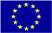  The Programme is implemented by the Consortium of partners led by the State Border Guard of the Republic of Latvia:  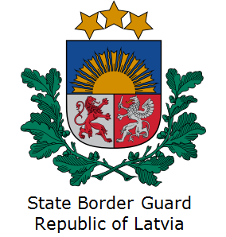 | This Programme is funded by the European Union  Delegation of the European Union to the Kyrgyz Republic  21 Erkindik Boulevard, Business Centre Orion, 5th floor  Bishkek, 720040, Kyrgyz Republic  Telephone: +996 312 26 10 00  Fax: +996 312 26 10 07  E-mail: delegation-kyrgyzstan@eeas.europa.eu  Website:http://eeas.europa.eu/delegations/kyrgyzstan  Facebook: http://www.facebook.com/eudelkg | The European Union is made up of 28 Member States who have decided to gradually link together their know-how, resources and destinies. Together, during a period of enlargement of 60 years, they have built a zone of stability, democracy and sustainable development whilst maintaining cultural diversity, tolerance and individual freedoms. The European Union is committed to sharing its achievements and its values with countries and peoples beyond its borders.

