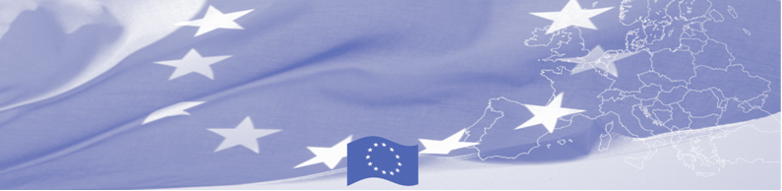
PRESS RELEASE

For release on 01 June 2016

BOMCA technical assistance mission visits Tajikistan

EU is continuing to offer significant support to border security activities in Central Asia. Thus, a technical assistance mission on management of mixed migration flows at borders starts in Dushanbe on June 01, 2016 within the framework of Border Management Programme in Central Asia (BOMCA). The mission envisages a mixture of a workshop and round-table discussions between the European experts from the State Border Guard of Latvia and Immigration and Borders Service of Portugal, on the one hand, and national experts working on the issue of trafficking in human beings and readmission, on the other hand. Local counterparts will be represented by the Ministry of Foreign Affairs, Border Troops of the State Security Committee, Ministry of Interior, and Migration Service of the Ministry of Labour, Migration and Employment.

The key objective of the mission is to discuss national legislation in line with international practices dealing with vulnerable groups of migrants passing through borders and explore legislation of the EU countries in relation to working with such migrant groups. Participants will discuss good practices from the EU MSs and Tajikistan in countering trafficking in human beings and smuggling of persons at the borders, as well as exchange their experience and learn about EU best practices in readmission.

Based on discussions and exchange of views with the national experts, the EU experts will develop recommendations on amendments of specific pieces of the national legislation related to management of vulnerable migrant groups at borders and readmission in line with international best practices.

First BOMCA operations began in Central Asia in 2003, and since then, BOMCA has strengthened partnership of the Central Asia Governments in the field of border management. The European Union allocated a sum of EUR 33.6 million to BOMCA for the period of 2003 – 2014 and almost EUR 5 million for its 9th implementation phase (2015 - 2018).

For more information please contact BOMCA in Tajikistan – +992 43 3779708 or jafar.usmanov@icmpd.org

  The Programme is imple-mented by the Consortium of partners led by the State Border Guard of the Republic of Latvia:  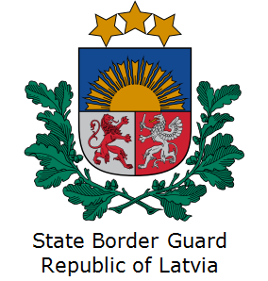 | This Programme is funded by the European Union  Delegation of the European Union to  Tajikistan  74 Adhamov street  734013 Dushanbe  Republic of Tajikistan  Phone: +992 37 221-74-07  Fax: +992 37 221-43-321  E-mail: Delegation-Tajikistan@eeas.europa.eu | The European Union is made up of 28 Member States who have decided to gradually link together their know-how, resources and destinies. Together, during a period of enlargement of 60 years, they have built a zone of stability, democracy and sustainable development whilst maintaining cultural diversity, tolerance and individual freedoms. The European Union is committed to sharing its achievements and its values with countries and peoples beyond its borders.

