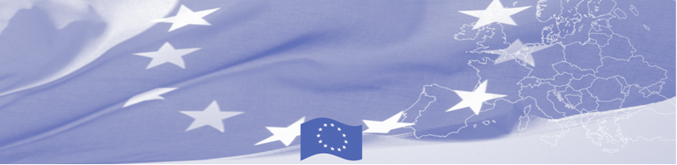
PRESS RELEASE

BOMCA transfers the equipment to Tajik Border Troops

Dushanbe, 02 August 2018

The EU continues to provide significant assistance to activities aimed at border security in Central Asia. As a part of the technical assistance provided in the region, 70 sets of video surveillance systems special stations with a total cost of 48,000 euros have been purchased and transferred to the Border Troops within the European Union funded Border Management Programme in Central Asia (BOMCA 9).

The purchased systems, consisting of servers, in-door and outdoor IP cameras, LED monitors and hard drives, will strengthen the capacities of technical equipment of the border service at remote border crossing points, which will allow to carry out better profiling of persons crossing the border, to create, store and analyse data on perpetrators and potentially dangerous persons and to efficiently transmit information to the Central office of the Tajik Border Troops.

The first BOMCA operations in Central Asia began in 2003 and, since then, BOMCA has strengthened the partnership between Central Asian Governments in the field of border management. The European Union allocated a sum of EUR 40, 1 million to BOMCA for the period of 2003 – 2019, out of which EUR 6, 6 million were assigned to its 9th implementation phase (2015 - 2019).

For more information, please visit web-site www.bomca-eu.org or contact Mr. Saidmusayab Alyamov, BOMCA National Coordinator for Tajikistan – said.alyamov@icmpd.org

  The Programme is imple-mented by the Consortium of partners led by the State Border Guard of the Republic of Latvia:  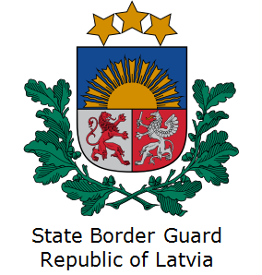 | This Programme is funded by the European Union  Delegation of the European Union to  Tajikistan  74 Adhamov street, 734013 Dushanbe  Republic of Tajikistan  Phone: +992 37 221-74-07  Fax: +992 37 221-43-321  E-mail: Delegation-Tajikistan@eeas.europa.eu | The European Union is made up of 28 Member States who have decided to gradually link together their know-how, resources and destinies. Together, during a period of enlargement of 60 years, they have built a zone of stability, democracy and sustainable development whilst maintaining cultural diversity, tolerance and individual freedoms. The European Union is committed to sharing its achievements and its values with countries and peoples beyond its borders.

