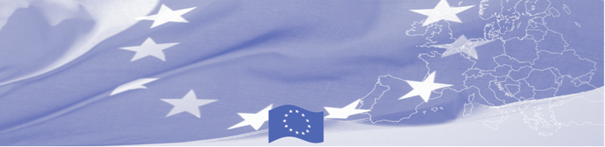
PRESS RELEASE

Kazakhstan hosts the 3rd Conference for Regional Cooperation in the Field of Border Security

Borovoe, July 24th, 2018

The 3rd Conference for Regional Cooperation in the Field of Border Security (Issyk-Kul Initiative) takes place on July 24th-25th, 2018, in Borovoe, Kazakhstan, and is organised by the EU-funded Programme of Border Management in Central Asia (BOMCA). It is expected to welcome over 50 guests - including the Heads and senior officials from border agencies of Afghanistan, Iran, Kazakhstan, Kyrgyzstan, Tajikistan, Turkmenistan and Uzbekistan. International organisations, such as EU-BOMNAF, FRONTEX working in the field of border security and management, will contribute to the results of this event.

Since 2011, under the framework of the Issyk-Kul Initiative, Central Asian border agencies come together in a regional forum for cooperation and information exchange in the field of border security in Central Asia.

This 3rd Conference focuses particularly on ways to address cross-border challenges in Central Asia. The key topics on the agenda for the thematic panel discussions are as follows: general challenges in the field of border management in Central Asia and Afghanistan; the gradual introduction of integrated border management and its advantages of more effective border management; and the needs and priorities for capacity building in border agencies of Central Asia and Afghanistan. During these panel discussions, the delegates will review the results achieved in border management and security in the recent past in Central Asia, the coordination among States and international stakeholders, and identify possible follow-up activities to further promote border management and security in the region.

For more information please contact Ms. Janna Tashieva, BOMCA Regional Communications Officer –
+ 996 312 902576 or janna.tashieva@icmpd.org

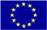  The Programme is imple-mented by the Consortium of partners led by the State Border Guard of the Republic of Latvia:  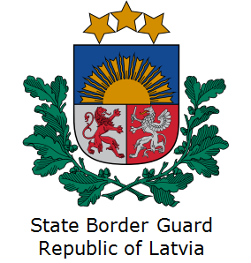 | This Programme is funded by the European Union  Delegation of the European Union to the Kyrgyz Republic  21 Erkindik Boulevard, Business Centre Orion, 5th floor  Bishkek, 720040, Kyrgyz Republic  Telephone: +996 312 26 10 00  Fax: +996 312 26 10 07  E-mail: delegation-kyrgyzstan@eeas.europa.eu  Website:http://eeas.europa.eu/delegations/kyrgyzstan  Facebook: http://www.facebook.com/eudelkg | The European Union is made up of 28 Member States who have decided to gradually link together their know-how, resources and destinies. Together, during a period of enlargement of 60 years, they have built a zone of stability, democracy and sustainable development whilst maintaining cultural diversity, tolerance and individual freedoms. The European Union is committed to sharing its achievements and its values with countries and peoples beyond its borders.

