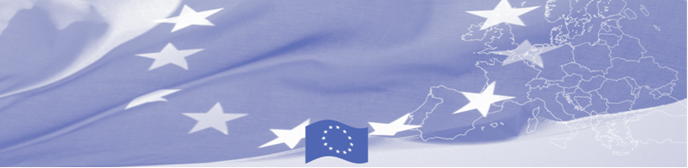
PRESS RELEASE

BOMCA transfers the equipment to Kyrgyz Border Service

Bishkek, 19 April 2018

The EU continues to provide significant assistance to activities aimed at border security in Central Asia. As a part of the technical assistance provided in the region, 19 sets of video surveillance systems special stations with a total cost of 41,000 euros have been purchased and transferred to the Border Service within the European Union funded Border Management Programme in Central Asia (BOMCA).

The purchased systems, consisting of servers, in-door and outdoor IP cameras, LED monitors and hard drives, will strengthen the technical equipment of the border service at remote border crossing points, which will allow to carry out better profiling of persons crossing the border, to create, store and analyse data on perpetrators and potentially dangerous persons and to efficiently transmit information to the Central office of the Border Service.

This is not the only provision of technical support by the BOMCA program to the Kyrgyz Border Service. In 2017 BOMCA bought and transferred the videoconferencing equipment for distance learning system, which was launched in border guarding training institutions in Kyrgyzstan. Thanks to the system, the Kyrgyz Border Service, its Training Centre in Osh and Military Institute are able connect to each other and also to receive guest videolectures from abroad.

The first BOMCA operations in Central Asia began in 2003 and, since then, BOMCA has strengthened the partnership between Central Asian Governments in the field of border management. The European Union allocated a sum of EUR 40, 1 million to BOMCA for the period of 2003 – 2019, out of which EUR 6, 6 million were assigned to its 9th implementation phase (2015 - 2019).

For more information please contact BOMCA in Kyrgyzstan – +996770661414 or janna.tashieva@icmpd.org

  The Programme is imple-mented by the Consortium of partners led by the State Border Guard of the Republic of Latvia:  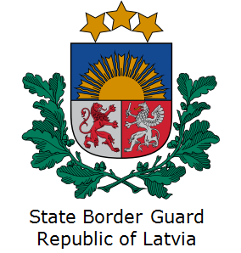 | This Programme is funded by the European Union  Delegation of the European Union to the Kyrgyz Republic  21 Erkindik Boulevard, Business Centre Orion, 5th floor  Bishkek, 720040, Kyrgyz Republic  Telephone: +996 312 26 10 00  Fax: +996 312 26 10 07  E-mail: delegation-kyrgyzstan@eeas.europa.eu  Website:http://eeas.europa.eu/delegations/kyrgyzstan  Facebook: http://www.facebook.com/eudelkg | The European Union is made up of 28 Member States who have decided to gradually link together their know-how, resources and destinies. Together, during a period of enlargement of 60 years, they have built a zone of stability, democracy and sustainable development whilst maintaining cultural diversity, tolerance and individual freedoms. The European Union is committed to sharing its achievements and its values with countries and peoples beyond its borders.

