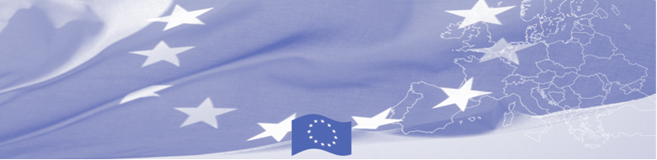
PRESS RELEASE

New regional manager of BOMCA Programme is appointed

Bishkek, June 07, 2018

EU-funded Border Management in Central Asia Programme (BOMCA 9) is pleased to announce that Col. Maris Domins is appointed as the new Regional Manager. He will be taking over the position from Raitis Tiliks, who has been holding this position since September 2015. Maris Domins will assume his duties as of June 15, 2018.

Maris Domins joined BOMCA after a 10 - year tenure as a Head of International Cooperation Department of Latvian State Border Guard, which is leading partner of BOMCA 9 implementing Consortium. Being Leader of one of the Programme Components, he was also actively involved in Programme management board since 9th phase launch in 2015.

Serving for more than 2 years as BOMCA Regional Manager, Raitis Tiliks will resume his duties in State Border Guard of Latvia. Raitis Tiliks’ contribution to the Programme was acknowledged by beneficiaries - he was awarded by the medal of the State Customs Service of Kyrgyz Republic.

For more information, please contact Ms. Janna Tashieva, BOMCA National Coordinator for Kyrgyzstan – janna.tashieva@icmpd.org

  The Programme is implemented by the Consortium of partners led by the State Border Guard of the Republic of Latvia:  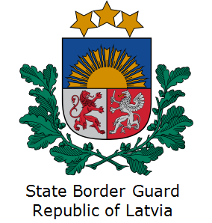 | This Programme is funded by the European Union  Delegation of the European Union to the Kyrgyz Republic  21 Erkindik Boulevard, Business Centre Orion, 5th floor  Bishkek, 720040, Kyrgyz Republic  Telephone: +996 312 26 10 00  Fax: +996 312 26 10 07  E-mail: delegation-kyrgyzstan@eeas.europa.eu  Website:http://eeas.europa.eu/delegations/kyrgyzstan  Facebook: http://www.facebook.com/eudelkg | The European Union is made up of 28 Member States who have decided to gradually link together their know-how, resources and destinies. Together, during a period of enlargement of 60 years, they have built a zone of stability, democracy and sustainable development whilst maintaining cultural diversity, tolerance and individual freedoms. The European Union is committed to sharing its achievements and its values with countries and peoples beyond its borders.

