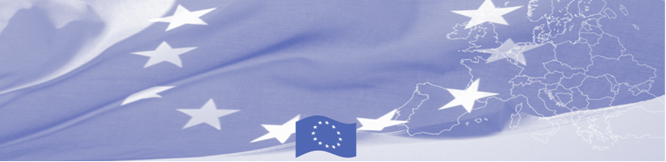
PRESS RELEASE

BOMCA and its national partners monitor project results and define plans for the future
Bishkek, 25 May 2018

A new round of national Steering Group meetings was held in Kazakhstan, Kyrgyzstan, Tajikistan and Uzbekistan, within the framework of the EU-funded Border Management in Central Asia Programme (BOMCA). Key partners from the beneficiary agencies, as well as EU representatives participated in these meetings and reconfirmed their commitment towards the implementation of the project and achievement of project goals. Together with the BOMCA management team, participants defined the directions for the upcoming activities in 2018 and 2019.
The meetings reinforced, once more, that the project is on the right track towards achieving the set objectives, by looking at the progress and lessons learned during the past years of implementation. The beneficiaries, in their turn, provided feedback on BOMCA activities implemented so far and provided a follow-up on the BOMCA recommendations developed and shared. Partners were given the possibility to share their opinions and ideas that came out of the participation in the BOMCA activities so far as well as provide their recommendations for the successful implementation of activities planned for the extension period.
To date, 247 activities were implemented within the framework of BOMCA 9 Programme in all Central Asia countries, with the participation of over 2 319 officials of Central Asian border, customs, and veterinary/phytosanitary agencies.
The National Steering Group Meetings continue to serve a basis for monitoring progress towards project goals and a reference point for facilitating co-operation and partnerships with the beneficiaries during the implementation phase.
The first BOMCA operations in Central Asia began in 2003 and, since then, BOMCA has strengthened the partnership between Central Asian Governments and Agencies in the field of border management. The European Union has allocated a sum of EUR 40.1 million to BOMCA for the period of 2003 – 2019, out of which more than EUR 6.6 million were assigned to its 9th implementation phase (2015 - 2019).

For more information, please visit web-site www.bomca-eu.org or contact Ms. Janna Tashieva, BOMCA National Coordinator for Kyrgyzstan – janna.tashieva@icmpd.org

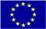  The Programme is imple-mented by the Consortium of partners led by the State Border Guard of the Republic of Latvia:  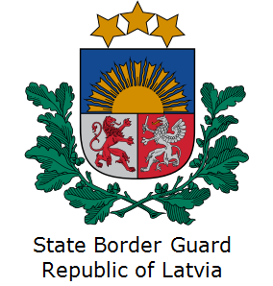 | This Programme is funded by the European Union  Delegation of the European Union to the Kyrgyz Republic  21 Erkindik Boulevard, Business Centre Orion, 5th floor  Bishkek, 720040, Kyrgyz Republic  Telephone: +996 312 26 10 00  Fax: +996 312 26 10 07  E-mail: delegation-kyrgyzstan@eeas.europa.eu  Website:http://eeas.europa.eu/delegations/  kyrgyzstan  Facebook:http://www.facebook.com/eudelkg | The European Union is made up of 28 Member States who have decided to gradually link together their know-how, resources and destinies. Together, during a period of enlargement of 60 years, they have built a zone of stability, democracy and sustainable development whilst maintaining cultural diversity, tolerance and individual freedoms. The European Union is committed to sharing its achievements and its values with countries and peoples beyond its borders.

