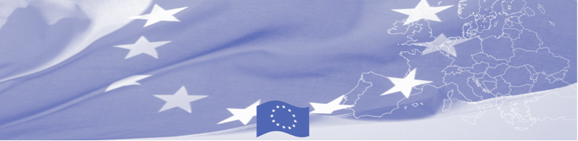
PRESS RELEASE

BOMCA holds first National Steering Group meeting in Ashgabat
For release on 27 May 2016

On May 27, BOMCA Programme in Turkmenistan hosted the National Steering Group meeting, which gathered main BOMCA national counterparts from Turkmenistan – State Border Service, State Customs Service, State Service on Plant Quarantine and State Veterinary Service of the Ministry of Agriculture and Water Resources, State Sanitary-epidemiologic Service of the Ministry of Health and Medical Industry of Turkmenistan as well as representatives of the EU and BOMCA programme consortium.

The purpose of the NSG meeting was to discuss the implementation aspects of BOMCA Programme, such as progress achieved, lessons learnt, and modalities of the future activities. The meeting was important not only in terms of discussing plans for the rest of the year, but also laid a foundation for further cooperation and established a forum for presentation of achievements, evaluation of results and valuable feedback from national partners. The participants acknowledged substantial work done by Turkmenistan in the area of border management and trade facilitation in order to promote trade flows with neighbouring countries but also to enhance security at border crossings. This is particularly relevant in the run-up to the Asian Indoor and Martial Arts Games (AIMAG) taking place in September 2017 and the role of the country in connectivity projects.
National Steering Groups (NSG), consisting of the representatives of the main national beneficiary agencies, have been established in each of 5 Central Asian countries. These meetings are held on a regular basis and present an important coordination mechanism for implementation of the programme at the national level.
First BOMCA operations began in Central Asia in 2003, and since then, BOMCA has strengthened partnership of the Central Asia Governments in the field of border management. The European Union allocated a sum of EUR 33.6 million to BOMCA for the period of 2003 – 2014 and almost EUR 5 million for its 9th implementation phase (2015 - 2018).
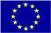  The Programme is implemented by the Consortium of partners led by the State Border Guard of the Republic of Latvia:  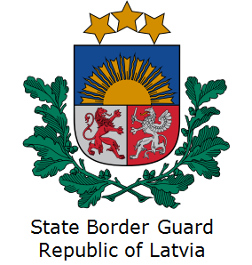 | This Programme is funded by the European Union  European Union Liaison Office in Turkmenistan  Pervy Proezd Myati Kosaeva, 8, Ashgabat. Tel: +99 312 34-46-77  E-mail: delegation-turkmenistan@eeas.europa.eu | The European Union is made up of 28 Member States who have decided to gradually link together their know-how, resources and destinies. Together, during a period of enlargement of 60 years, they have built a zone of stability, democracy and sustainable development whilst maintaining cultural diversity, tolerance and individual freedoms. The European Union is committed to sharing its achievements and its values with countries and peoples beyond its borders.

