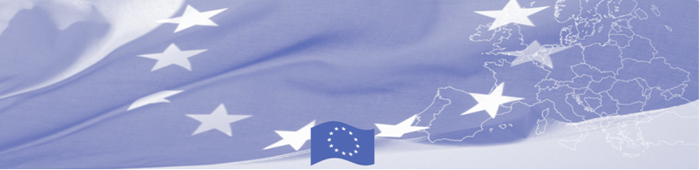
PRESS-RELEASE

Strengthening of Interagency Cooperation on Joint Risk Analysis of Border Security

Tashkent, 17 April 2018

The EU continues offering significant support to border security activities in Central Asia. Thus on 17-19 April 2018 Tashkent will host the national workshop on strengthening of interagency cooperation on joint risk analysis of border security to be conducted within the framework of the EU-funded Border Management in Central Asia Programme (BOMCA 9).

The workshop will be facilitated by the EU Experts Ms. Sandra Karklina-Admine, Director of Tax Control Department of the State Revenue Service, and Mr. Mariks Petrusins, Director of Border Guard College of the State Border Guard of the Republic of Latvia.

The main goal of the workshop is to strengthen the inter-agency cooperation and development of practical recommendations for joint risk analysis of border security for the law enforcement agencies that will include practical implementation of the concept elements on integrated border management at all departmental levels (central, regional, local). Taking the results of the joint work with beneficiaries, the EU experts will develop recommendations on joint risk analysis of border security, as well as improvement of the existing practice of risk analysis by border agencies.

The Border Management Programme in Central Asia (BOMCA) launched its activities in 2003 to strengthen partnership between the Central Asian governments in the area of border management. The EU allocated more than EUR 40 mln to BOMCA for 2003-2018, while almost EUR 5 mln were assigned for implementation of the 9th phase of the Programme for 2015-2018.

For more information on the event and the activity of BOMCA Programme, please visit www.bomca-eu.org, or contact Ms. Zulfiya Sibagatulina, BOMCA National Coordinator for Uzbekistan at zulfiya.sibagatulina@icmpd.org

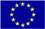  The Programme is imple-mented by the Consortium of partners led by the State Border Guard of the Republic of Latvia:  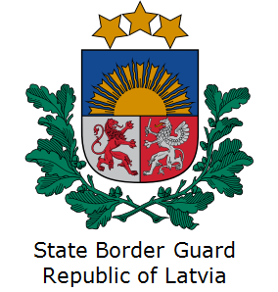 | This Programme is funded by the European Union  Delegation of the European Union to the Republic of Uzbekistan  International Business Centre,  107 B Amir Temur Street  100 084 Tashkent, Uzbekistan  Telephone: +998 71 120 16 01/02/03/04  Fax: +998 71 120 16 08  E-mail: delegation-uzbekistan@eeas.europa.eu  Website: http://www.eeas.europa.eu/delegations/uzbekistan | The European Union is made up of 28 Member States who have decided to gradually link together their know-how, resources and destinies. Together, during a period of enlargement of 60 years, they have built a zone of stability, democracy and sustainable development whilst maintaining cultural diversity, tolerance and individual freedoms. The European Union is committed to sharing its achievements and its values with countries and peoples beyond its borders.

