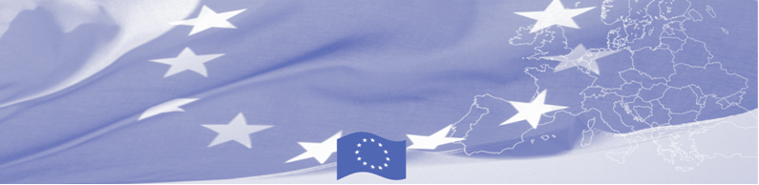
PRESS RELEASE

BOMCA transfers equipment to the Border Service of Kazakhstan

Astana, 05 April 2018

The EU continues to provide significant assistance to activities aimed at border security in Central Asia. As a part of the technical equipment provided in the region, 35 work stations (laptops) with a total cost of 48,000 euros have been purchased and transferred to the Border Service of the Committee of National Security of the Republic of Kazakhstan within the European Union funded Border Management Programme in Central Asia – Phase 9 (BOMCA 9).

The purchased laptops will strengthen the technical capabilities of Kazakhstan Border Service at remote Border Crossing Points (BCPs), and will allow to increase operability of persons’ profiling at the border, to create, store and analyse data on perpetrators and to efficiently transmit information to the Central Office of the Border Service. Shortly these stations will be integrated into a unified IT system of the Border Service.

This is not the first provision of technical support by the EU-funded BOMCA Programme to the Border Service of the CNS of Kazakhstan. In 2006, the Border Control Centre in Almaty was renovated and equipped with support of BOMCA. In 2007, classrooms at the BCP "Merke-Railway" was renovated and equipped. In 2008, a computer lab for English training at the Border Guards Academy of CNS RK in Almaty was equipped.

The first BOMCA operations in Central Asia began in 2003 and, since then, BOMCA has strengthened the partnership between Central Asian Governments and Agencies in the field of border management. The European Union has allocated a sum of EUR 40.1 million to BOMCA for the period of 2003 – 2019, out of which more than EUR 6.6 million were assigned to its 9th implementation phase (2015 - 2019).

For more information please contact BOMCA in Kazakhstan – +7 701 532 02 64 or amir.yelchibekov@icmpd.org

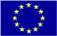  The Programme is implemented by the Consortium of the EU partners led by the State Border Guard of the Republic of Latvia:  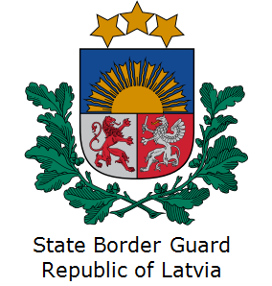 | This Programme is funded by the European Union  Delegation of the European Union to  Kazakhstan  62, Kosmonavtov street, 4th floor  Astana, 010000, Republic of Kazakhstan  Telephone: + 7 7172 97 45 40, 97-11-48  Fax: + 7 7172 97 95 63  E-mail: Delegation-Kazakhstan@eeas.europa.eu  Website:http://eeas.europa.eu/delegations/Kazakhstan  Website: https://www.bomca-eu.org | The European Union is made up of 28 Member States who have decided to gradually link together their know-how, resources and destinies. Together, during a period of enlargement of 60 years, they have built a zone of stability, democracy and sustainable development whilst maintaining cultural diversity, tolerance and individual freedoms. The European Union is committed to sharing its achievements and its values with countries and peoples beyond its borders.

