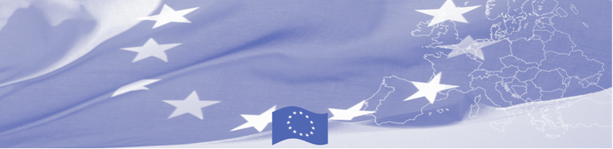
PRESS RELEASE

Almaty hosts a Regional Training of Trainers on profiling at border check points

Almaty, 27 February 2018

Taking into account the significant number of people moving within the Central Asia borders and crossing the region in transit, the EU is continuing to offer significant support to border security activities in Central Asia. Thus, on February 27-29 a Regional Training of Trainers on profiling at border checkpoints will be held in Almaty organized by EU-funded Border Management in Central Asia Programme (BOMCA) in cooperation with OSCE Programme Office and INL Bureau (US Embassy). The event will gather lecturers of training itutions from Kazakhstan, Kyrgyzstan, Uzbekistan and Turkmenistan.

The main goal of the activity is to present to the participants different teaching methods of profiling topic and to exchange best practices. The participants will learn about Kazakh approach in this area and share their experiences. As a result joint recommendations will be elaborated regarding quality of education and professional development of personnel of border guarding training institutions in the area of profiling teaching.

Through theoretical and practical exercises, the participants will learn the approach of their Kazakh colleagues in teaching such profiling aspects as operational psychodiagnosis, lie detection, talk analysis, methods of questioning etc. The participants will have a tour to the Border Service Academy of State Security Committee of Kazakhstan and see the training models of border checkpoints and examination polygons.

The training intends not only to enhance the professional development of border agencies training institutions and provide the basic curriculum with visual materials, but also to improve networking among the Central Asian border agencies by developing a regional list of contacts of the experts for information exchange on documents security.

The first BOMCA operations in Central Asia began in 2003 and, since then, BOMCA has strengthened the partnership between Central Asian Governments in the field of border management. The European Union allocated a sum of EUR 40,8 million to BOMCA for the period of 2003 – 2018, out of which almost EUR 5 million were assigned to its 9th implementation phase (2015 - 2018).

For more information please contact Mr Amir Yelchibekov, BOMCA National Coordinator for Kazakhstan, tel: +7 (701) 532 02 64, e-mail: amir.yelchibekov@icmpd.org

  The Programme is imple-mented by the Consortium of partners led by the State Border Guard of the Republic of Latvia:  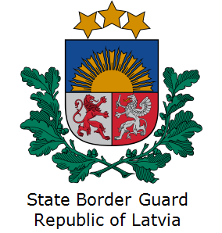 | This Programme is funded by the European Union  Delegation of the European Union to Kazakhstan  62, Kosmonavtov street, 4th floor  Astana, 010000, Republic of Kazakhstan  Telephone: + 7 7172 97 45 40,  Fax: + 7 7172 97 45 41  E-mail: Delegation-Kazakhstan@eeas.europa.eu  Website:http://eeas.europa.eu/delegations/Kazakhstan  Website: https://www.bomca-eu.org | The European Union is made up of 28 Member States who have decided to gradually link together their know-how, resources and destinies. Together, during a period of enlargement of 60 years, they have built a zone of stability, democracy and sustainable development whilst maintaining cultural diversity, tolerance and individual freedoms. The European Union is committed to sharing its achievements and its values with countries and peoples beyond its borders

