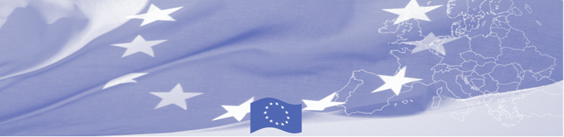
PRESS-RELEASE

February 3, 2016

Astana hosts a national workshop on compatibility of customs legislation applied in Kazakhstan with the provisions of the revised Kyoto Convention.

ASTANA – A workshop on compatibility of customs legislation applied in Kazakhstan with the provisions of the revised Kyoto Convention starts in Astana on 3 February gathering national experts from the State Revenue Committee of the Ministry of Finance of the Republic of Kazakhstan and Financial Academy. This workshop is conducted within the framework of Border Management Programme in Central Asia (BOMCA), funded by the European Union and will be held by EU experts Rimantas Rackauskas and Vida Mickiene. Opening speech will be delivered by Mr. Kamen Velichkov, Chargé d’affaires of the Delegation of the European Union to Kazakhstan and Mr.Jurijs Pogrebnaks, Ambassador of Latvia to Kazakhstan.

During this three-day activity national customs officers will discuss international standards and principles for advanced and effective customs control set out in revised Kyoto Convention, in particular related to customs control arrangement at the checkpoints, declaration of goods, payment of customs duties and taxes. As the result of the workshop a comparative analysis including recommendations will be prepared, which will reflect compatibility of customs legislation applied in Kazakhstan with the provisions of the Revised Kyoto Convention.

The overall objective of current phase of BOMCA Programme is to increase effectiveness and efficiency of border management in Central Asia by introducing advanced elements of the Integrated Border Management (IBM), assisting governments in developing and reforming their migration governance, mobility and trade facilitation policies and strengthening capacities of Border and Migration Agencies. First BOMCA operations began in Central Asia in 2003, and since then, BOMCA has strengthened partnership of the Central Asia Governments in the field of border management. The European Union allocated a sum of EUR 33.6 million to BOMCA for the period of 2003 – 2014 and almost EUR 5 million for its 9th implementation phase (2015 - 2018).

For more information please contact Ms Karla Jamankulova, Press and Information Officer of the Delegation of the European Union to the Republic of Kazakhstan at Karlygash.JAMANKULOVA@eeas.europa.eu, or Mr. Amir Yelchibekov, BOMCA National Coordinator for Kazakhstan - (+7 701) 532 02 64 or amir.yelchibekov@icmpd.org.
  The Programme is imple-mented by the Consortium of partners led by the State Border Guard of the Republic of Latvia:  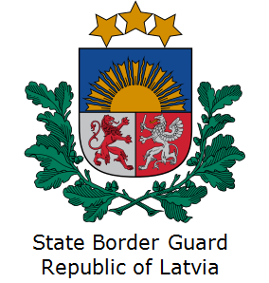 | This Programme is funded by the European Union  Delegation of the European Union to Kazakhstan  62, Kosmonavtov street, 4th floor  Astana, 010000, Republic of Kazakhstan  Telephone: + 7 7172 97 10 40, 97-11-48  Fax: + 7 7172 97 95 63  E-mail: Delegation-Kazakhstan@eeas.europa.eu  Website:http://eeas.europa.eu/delegations/Kazakhstan  Website: https://www.bomca-eu.org | The European Union is made up of 28 Member States who have decided to gradually link together their know-how, resources and destinies. Together, during a period of enlargement of 60 years, they have built a zone of stability, democracy and sustainable development whilst maintaining cultural diversity, tolerance and individual freedoms. The European Union is committed to sharing its achievements and its values with countries and peoples beyond its borders.

