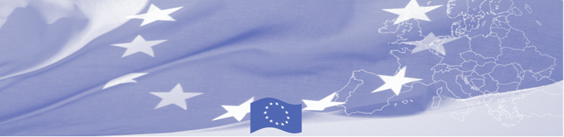
PRESS-RELEASE

Dog Handlers of Uzbekistan Law Enforcement Agencies
Improve Professional Skills
Tashkent, 06 February 2018

A three-day national training course for canine officers of border and customs agencies of Uzbekistan will be held in Tashkent on 6-8 February 2018. The training is organized within the framework of the Border Management Program in Central Asia (BOMCA), funded by the European Union. Dog handlers from the State Border Guard Committee of the National Security Service and Customs Committee of Uzbekistan will be able to perform their professional skills and study international best practices, as well as share their personal experience.

International experts will present best practices in developing and improving long-term, high-efficient and high-quality work of the Canine Service, will present the organizational work of the canine services in the EU countries, cooperation with other law enforcement agencies and at the international level. Particular attention will be paid to innovative methods of education and training of service dogs and creation of motivating conditions for the professional development of dog handlers. The training will contribute to the development of professional potential of dog handlers of law enforcement agencies of Uzbekistan.

The Border Management Programme in Central Asia (BOMCA) launched its activities in 2003 to strengthen partnership between the Central Asian governments in the area of border management. The EU allocated more than EUR 40 mln to BOMCA for 2003-2018, while almost EUR 5 mln were assigned for implementation of the 9th phase of the Programme for 2015-2018.

For more information on the event and the activity of BOMCA Programme, please visit www.bomca-eu.org, or contact Ms. Zulfiya Sibagatulina, BOMCA National Coordinator for Uzbekistan at zulfiya.sibagatulina@icmpd.org

  The Programme is imple-mented by the Consortium of partners led by the State Border Guard of the Republic of Latvia:  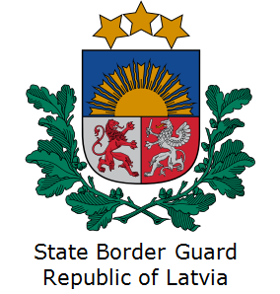 | This Programme is funded by the European Union  Delegation of the European Union to the Republic of Uzbekistan  International Business Centre,  107 B Amir Temur Street  100 084 Tashkent, Uzbekistan  Telephone: +998 71 120 16 01/02/03/04  Fax: +998 71 120 16 08  E-mail: delegation-uzbekistan@eeas.europa.eu  Website: http://www.eeas.europa.eu/delegations/uzbekistan | The European Union is made up of 28 Member States who have decided to gradually link together their know-how, resources and destinies. Together, during a period of enlargement of 60 years, they have built a zone of stability, democracy and sustainable development whilst maintaining cultural diversity, tolerance and individual freedoms. The European Union is committed to sharing its achievements and its values with countries and peoples beyond its borders.

