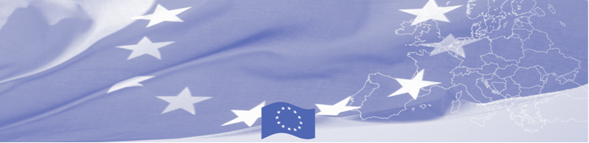
PRESS RELEASE

State Customs of the Kyrgyz Republic strengthening its anti-corruption measures

Bishkek, 29 January 2018

On January 29 the team of European experts will visit the Kyrgyz Republic with the aim to provide support to the Government in implementation of anti-corruption measures. The technical assistance mission is organised by the Border Management in Central Asia Programme (BOMCA), funded by the European Union.

In particular, invited experts will gather with the nominated representatives from the State Customs Service and review the internal legislation of the Customs Service, its organisational structure and factors that could increase risks of corruption. The list of essential corruption risks will be developed with the analysis of preconditions, organisational structure, functional duties and procedures. The organisational structure of the agencies will be then analysed in terms of compliance to tasks, competencies, rights and obligations of the staff. As a result of intensive five days joint work, an existent anti-corruption action plan will be evaluated and recommendations provided on it improvement and advancement.

From the wider perspective, this BOMCA activity is related to strengthening professional and ethical standards of the law-enforcement agencies (work relations and environment, intra and inter agency cooperation, anticorruption) in compliance with international and European standards and is planned to be conducted in all five Central Asian countries.

The first BOMCA operations in Central Asia began in 2003 and, since then, BOMCA has strengthened the partnership between Central Asian Governments in the field of border management. The European Union and its partners allocated a sum of EUR 40,8 million to BOMCA for the period of 2003 – 2018, out of which almost EUR 5 million were assigned to its 9th implementation phase (2015 - 2018).

For more information please contact Ms. Janna Tashieva, BOMCA Regional Communications Officer – + 996 312 394071 or janna.tashieva@icmpd.org
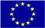  The Programme is imple-mented by the Consortium of partners led by the State Border Guard of the Republic of Latvia:  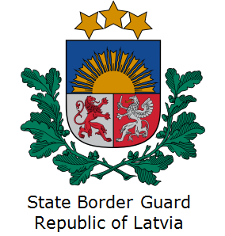 | This Programme is funded by the European Union  Delegation of the European Union to the Kyrgyz Republic  21 Erkindik Boulevard, Business Centre Orion, 5th floor  Bishkek, 720040, Kyrgyz Republic  Telephone: +996 312 26 10 00  Fax: +996 312 26 10 07  E-mail: delegation-kyrgyzstan@eeas.europa.eu  Website:http://eeas.europa.eu/delegations/  kyrgyzstan  Facebook:http://www.facebook.com/eudelkg | The European Union is made up of 28 Member States who have decided to gradually link together their know-how, resources and destinies. Together, during a period of enlargement of 60 years, they have built a zone of stability, democracy and sustainable development whilst maintaining cultural diversity, tolerance and individual freedoms. The European Union is committed to sharing its achievements and its values with countries and peoples beyond its borders.

