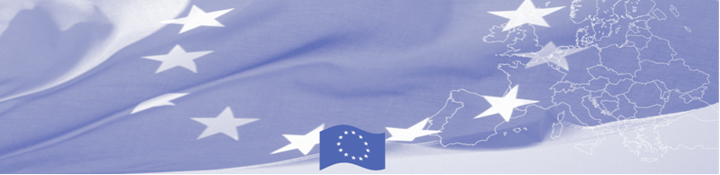
PRESS RELEASE

Border Management in Central Asia Programme (BOMCA)
sums up the achievements to date and outlines plans for the future

Astana, November 29, 2017

On November 29, Astana hosts the 3rd Regional Steering Group meeting of the European Union funded BOMCA 9 Programme in Central Asia. Representatives of Border Guard and Customs services, Foreign Affairs Ministries of all Central Asian countries, as project beneficiaries, together with BOMCA Consortium partners and EU Delegations in Kazakhstan and Kyrgyzstan will gather for the annual regional meeting. During the meeting the parties will jointly assess achievements of the Programme, successes and challenges to date, and discuss the work plan for the Programme extension period by the end of 2019. Furthermore, the meeting will touch upon the overall regional and national priorities for the coming years to explore further possible support to the border management in the region.

Since its start in 2003, BOMCA has been one of the flagship initiatives of the EU cooperation with all Central Asian countries in the area of border management and cross-border cooperation. The 9th phase of BOMCA builds upon the results and achievements of the previous decade of work in the region and specifically targets the areas of institutional development, management of mixed migration flows and trade facilitation. Starting from June 2015, over 1900 beneficiaries from 5 Central Asian countries have participated in 198 events of different scope – from national and regional workshops to technical assistance missions, on-the-job trainings and study visits to the EU Member States and Central Asian countries. In the first half of 2018 9th phase of BOMCA intends to conduct up to 30 activities.

The first BOMCA operations in Central Asia began in 2003 and, since then, BOMCA has strengthened the partnership between Central Asian Governments in the field of border management. The European Union and its partners allocated a sum of EUR 40,8 million to BOMCA for the period of 2003 – 2018, out of which almost EUR 5 million were assigned to its 9th implementation phase (2015 - 2018).

For more information, please visit web-site www.bomca-eu.org or contact Ms. Janna Tashieva, BOMCA National Coordinator for Kyrgyzstan – janna.tashieva@icmpd.org
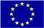  The Programme is implemented by the Consortium of partners led by the State Border Guard of the Republic of Latvia:  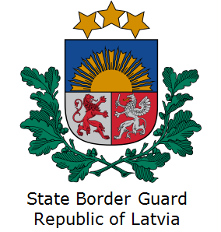 | This Programme is funded by the European Union  Delegation of the European Union to the Kyrgyz Republic  21 Erkindik Boulevard, Business Centre Orion, 5th floor  Bishkek, 720040, Kyrgyz Republic  Telephone: +996 312 26 10 00  Fax: +996 312 26 10 07  E-mail: delegation-kyrgyzstan@eeas.europa.eu  Website:http://eeas.europa.eu/delegations/kyrgyzstan  Facebook: http://www.facebook.com/eudelkg | The European Union is made up of 28 Member States who have decided to gradually link together their know-how, resources and destinies. Together, during a period of enlargement of 60 years, they have built a zone of stability, democracy and sustainable development whilst maintaining cultural diversity, tolerance and individual freedoms. The European Union is committed to sharing its achievements and its values with countries and peoples beyond its borders.

