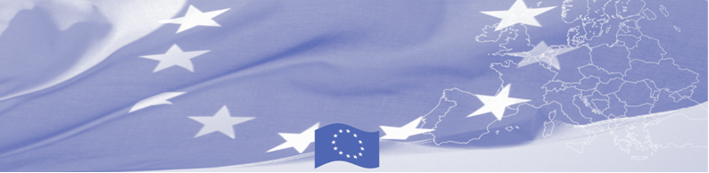
PRESS RELEASE

For release on May 23, 2016

EU BOMCA technical assistance mission takes place in Dushanbe

BOMCA invited expert comes to Dushanbe to provide technical assistance and recommendations on how to strengthen the risk analysis system and modern tools and approaches to green border monitoring. For this, EU expert meets key national partners from the Border Troops of the State Committee on National Security of the Republic of Tajikistan. This BOMCA activity aims to support the Border Troops in its efforts to improve the efficiency of green border surveillance and risk analysis development.

During the meeting the expert will present the EU practices in risk analysis and investigation of illegal “green border” crossing and together with national partners review and compare the existing national legislation related to green border monitoring with the EU legislation. Special focus of the meeting will be on legal framework of green border surveillance, technical means, planning of services and appropriate resources, search of violators.

Based on the meeting’s findings and joint discussions, the EU expert will develop and provide recommendations on improvement of the efficiency of existing procedures and monitoring mechanisms in Tajikistan as well as the green border surveillance tactics.

First BOMCA operations began in Central Asia in 2003, and since then, BOMCA has strengthened partnership of the Central Asia Governments in the field of border management. The European Union allocated a sum of EUR 33.6 million to BOMCA for the period of 2003 – 2014 and almost EUR 5 million for its 9th implementation phase (2015 - 2018).

For more information please contact Mr. Jafar Usmanov, BOMCA in Tajikistan – (+992 43) 377 97 08 or jafar.usmanov@icmpd.org

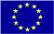  The Programme is imple-mented by the Consortium of partners led by the State Border Guard of the Republic of Latvia:  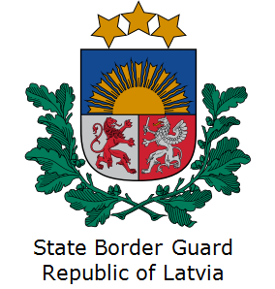 | This Programme is funded by the European Union  Delegation of the European Union to  Tajikistan  74 Adhamov street  734013 Dushanbe  Republic of Tajikistan  Phone: +992 37 221-74-07  Fax: +992 37 221-43-321  E-mail: Delegation-Tajikistan@eeas.europa.eu | The European Union is made up of 28 Member States who have decided to gradually link together their know-how, resources and destinies. Together, during a period of enlargement of 60 years, they have built a zone of stability, democracy and sustainable development whilst maintaining cultural diversity, tolerance and individual freedoms. The European Union is committed to sharing its achievements and its values with countries and peoples beyond its borders.

