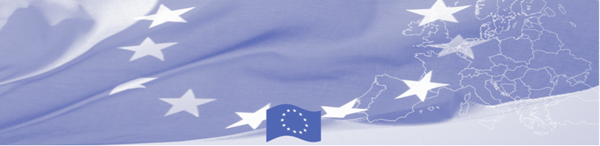
PRESS-RELEASE

Interagency cooperation issues are being discussed by border agencies of Turkmenistan

Ashgabat, November 7

Ashgabat hosts a workshop on interaction of state agencies involved in border control. Representatives of Border, Customs and Migration Services, Ministry of Agriculture and Water Economy, State Sanitary-Epidemiological Service discuss the issues of cooperation on border check points and assess international experience in this direction. The workshop is being facilitated by the programme experts of Border Management in Central Asia Programme, funded by the European Union.

Taking into the account that interagency cooperation and timely exchange of information at intra-, interagency and international levels are one of main constituents of effective implementation of Integrated Border Management, the workshop will be mainly focused on information exchange, analysing and structuring the data, information flows management within an agency and between the agencies and countries. Based on Latvia experience, an advanced example of effective cooperation between the agencies and States will be introduced to participants.

The first BOMCA operations in Central Asia began in 2003 and, since then, BOMCA has strengthened the partnership between Central Asian Governments in the field of border management. The European Union allocated a sum of EUR 40,8 million to BOMCA for the period of 2003 – 2018, out of which almost EUR 5 million were assigned to its 9th implementation phase (2015 - 2018).

For more information please contact Mr. Rustam Berdiyev, BOMCA National Coordinator for Turkmenistan, + 993 68 055707 or rustam.berdiyev.bomca@gmail.com

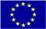  The Programme is imple-mented by the Consortium of partners led by the State Border Guard of the Republic of Latvia:  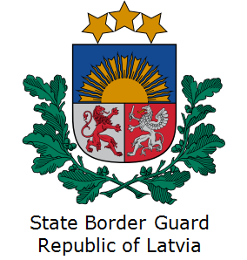 | This Programme is funded by the European Union  Delegation of the European Union to Turkmenistan  Pervy Proezd Myati Kosaeva, 8, Ashgabat. Tel: +993-12-349752  E-mail: delegation-turkmenistan@eeas.europa.eu | The European Union is made up of 28 Member States who have decided to gradually link together their know-how, resources and destinies. Together, during a period of enlargement of 60 years, they have built a zone of stability, democracy and sustainable development whilst maintaining cultural diversity, tolerance and individual freedoms. The European Union is committed to sharing its achievements and its values with countries and peoples beyond its borders.

