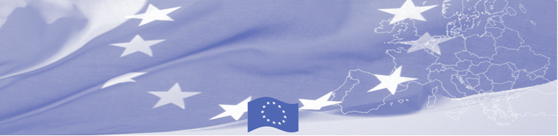
PRESS RELEASE

BOMCA is launching distance learning for education of border guards

Bishkek, 3 November 2017

BOMCA is introducing a new effective learning tool that could be used in education and retraining of border guards – distance learning system. Today the equipment was officially transferred and the system with its capabilities and advantages was presented to State Border Service and Military Armed Forces Institute.
Videoconferencing and lessons via video will provide students and teachers with an immersive, innovative learning experience that combines high-definition video and audio tools - officers and teachers will be able to connect to students in live regime without physically attending the classroom. The system will allow State Border Service of the Kyrgyz Republic, its Training Centre in Osh and Military Institute to connect to each other and also to receive guest videolectures from abroad.
The system will connect Training Centre of the State Border Service, Military Armed Forces Institute, Border Guard College in Latvia and Riga Technical University. A first pilot distance lecture was delivered today to Military Institute trainees by lecturers of Border College in Rezekne, Latvia.

The first BOMCA operations in Central Asia began in 2003 and, since then, BOMCA has strengthened the partnership between Central Asian Governments in the field of border management. The European Union allocated a sum of EUR 40,8 million to BOMCA for the period of 2003 – 2018, out of which almost EUR 5 million were assigned to its 9th implementation phase (2015 - 2018).

For more information, please visit web-site or contact Ms. Janna Tashieva, BOMCA National Coordinator for Kyrgyzstan – janna.tashieva@icmpd.org
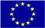  The Programme is implemented by the Consortium of partners led by the State Border Guard of the Republic of Latvia:  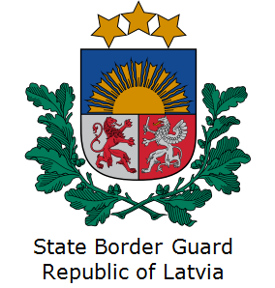 | This Programme is funded by the European Union  Delegation of the European Union to the Kyrgyz Republic  21 Erkindik Boulevard, Business Centre Orion, 5th floor  Bishkek, 720040, Kyrgyz Republic  Telephone: +996 312 26 10 00  Fax: +996 312 26 10 07  E-mail: delegation-kyrgyzstan@eeas.europa.eu  Website:http://eeas.europa.eu/delegations/kyrgyzstan  Facebook: http://www.facebook.com/eudelkg | The European Union is made up of 28 Member States who have decided to gradually link together their know-how, resources and destinies. Together, during a period of enlargement of 60 years, they have built a zone of stability, democracy and sustainable development whilst maintaining cultural diversity, tolerance and individual freedoms. The European Union is committed to sharing its achievements and its values with countries and peoples beyond its borders.

