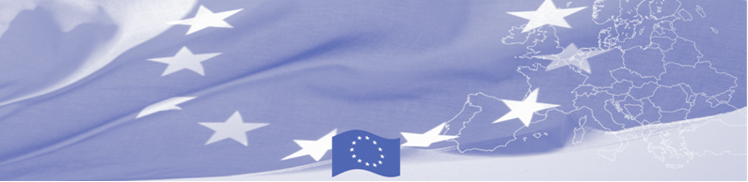
PRESS-RELEASE

September 13, 2017

Almaty is hosting a regional workshop on compatibility of customs legislation applied in Central Asian countries with the provisions of the revised Kyoto Convention.

On 13th of September in Almaty started a workshop on compatibility of customs legislation applied in Central Asia with the provisions of the revised Kyoto Convention, gathering national experts from Customs Services of Central Asian countries dealing with customs control arrangement. The workshop is conducted within the framework of Border Management in Central Asia Programme (BOMCA), funded by the European Union.

During this three days activity invited EU experts together with the national customs officers will discuss international standards and principles for advanced and effective customs control set out in revised Kyoto Convention, in particular related to customs control arrangement at the checkpoints, declaration of goods, payment of customs duties and taxes. European experts will present comparative analysis including recommendations, reflecting compatibility of customs legislation applied in Central Asia with the provisions of the Revised Kyoto Convention.

The first BOMCA operations in Central Asia began in 2003 and, since then, BOMCA has strengthened the partnership between Central Asian Governments in the field of border management. The European Union allocated a sum of EUR 40, 8 million to BOMCA for the period of 2003 – 2018, out of which almost EUR 5 million were assigned to its 9th implementation phase (2015 - 2018).

For more information, please visit web-site www.bomca-eu.org or contact Ms. Janna Tashieva, BOMCA National Coordinator for Kyrgyzstan – janna.tashieva@icmpd.org

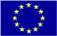  The Programme is imple-mented by the Consortium of partners led by the State Border Guard of the Republic of Latvia:  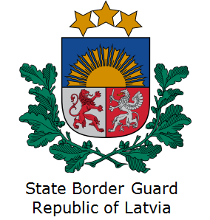 | This Programme is funded by the European Union  Delegation of the European Union to the Kyrgyz Republic  21 Erkindik Boulevard, Business Centre Orion, 5th floor  Bishkek, 720040, Kyrgyz Republic  Telephone: +996 312 26 10 00  Fax: +996 312 26 10 07  E-mail: delegation-kyrgyzstan@eeas.europa.eu  Website:http://eeas.europa.eu/delegations/  kyrgyzstan  Facebook:http://www.facebook.com/eudelkg | The European Union is made up of 28 Member States who have decided to gradually link together their know-how, resources and destinies. Together, during a period of enlargement of 60 years, they have built a zone of stability, democracy and sustainable development whilst maintaining cultural diversity, tolerance and individual freedoms. The European Union is committed to sharing its achievements and its values with countries and peoples beyond its borders.

