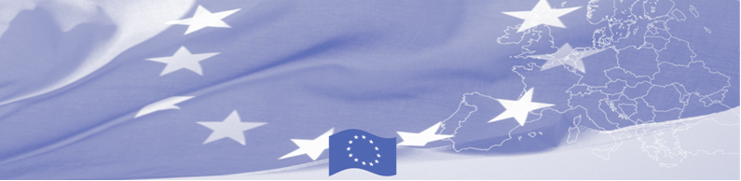
PRESS RELEASE

Vulnerable migrants’ assistance issues are being discussed in Bishkek

Bishkek, 13 September 2017

EU is continuing to offer significant support to border security activities in Central Asia. Thus, a technical assistance mission on proper assistance to vulnerable migrants starts in Bishkek on September 13, 2017 within the framework of Border Management Programme in Central Asia (BOMCA). The mission envisages a mixture of a workshop and round-table discussions between the European experts from the State Border Guard of Latvia and International Centre for Migration Policy Development, and national experts working on the issue of trafficking in human beings and readmission, on the other hand. Local counterparts will be represented by the Ministry of Foreign Affairs, Ministry of Interior, General Prosecutor Office, State Migration Service.

The key objective of the mission is to discuss national legislation in line with international practices dealing with vulnerable groups of migrants passing through borders and explore legislation of the EU countries in relation to working with such migrant groups. Participants will discuss good practices from the EU MSs and Kyrgyzstan in countering trafficking in human beings and smuggling of persons at the borders, as well as exchange their experience and learn about EU best practices in readmission.

Based on discussions and exchange of views with the national partners, the EU experts will develop recommendations on amendments of specific pieces of the national legislation related to management of vulnerable migrant groups at borders and readmission in line with international best practices.

The first BOMCA operations in Central Asia began in 2003 and, since then, BOMCA has strengthened the partnership between Central Asian Governments in the field of border management. The European Union allocated a sum of EUR 40, 8 million to BOMCA for the period of 2003 – 2018, out of which almost EUR 5 million were assigned to its 9th implementation phase (2015 - 2018).

For more information, please visit web-site www.bomca-eu.org or contact Ms. Janna Tashieva, BOMCA National Coordinator for Kyrgyzstan – janna.tashieva@icmpd.org

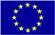  The Programme is implemented by the Consortium of partners led by the State Border Guard of the Republic of Latvia:  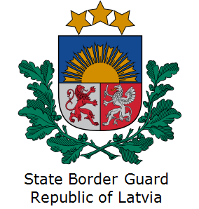 | This Programme is funded by the European Union  Delegation of the European Union to the Kyrgyz Republic  21 Erkindik Boulevard, Business Centre Orion, 5th floor  Bishkek, 720040, Kyrgyz Republic  Telephone: +996 312 26 10 00  Fax: +996 312 26 10 07  E-mail: delegation-kyrgyzstan@eeas.europa.eu  Website:http://eeas.europa.eu/delegations/kyrgyzstan  Facebook: http://www.facebook.com/eudelkg | The European Union is made up of 28 Member States who have decided to gradually link together their know-how, resources and destinies. Together, during a period of enlargement of 60 years, they have built a zone of stability, democracy and sustainable development whilst maintaining cultural diversity, tolerance and individual freedoms. The European Union is committed to sharing its achievements and its values with countries and peoples beyond its borders.

