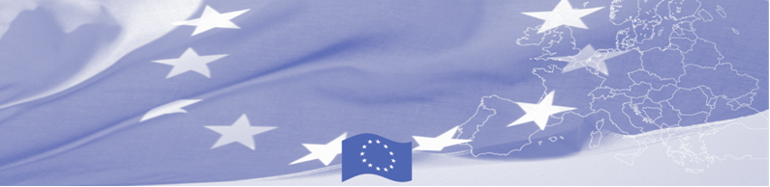
PRESS RELEASE

BOMCA holds second National Steering Group meeting in Tajikistan

For release on 30 June 2017

On June 30, BOMCA Programme hosted the National Steering Group meeting in Tajikistan, which gathered main BOMCA national counterparts – Ministry of Foreign Affairs, Border Service, Customs Service, Ministry of Interior, State Inspections on Phyto-sanitary and Veterinary Security, Ministry of Healthcare and Social Protection as well as representatives of the EU and BOMCA programme consortium.

The purpose of the NSG meeting was to discuss the implementation aspects of BOMCA Programme, such as progress achieved, lessons learnt, and modalities of the future activities. The meeting was important not only in terms of discussing plans for the rest of the year, but also laid a foundation for further cooperation and established a forum for presentation of achievements, evaluation of results and valuable feedback from national partners.
In the first half of 2017, over 112 Tajik beneficiaries took an active part in 8 national and regional activities, organized by BOMCA. Such strong commitment from Tajik side is expected also in 9 upcoming activities that are planned for the rest of the year.
National Steering Groups (NSG), consisting of the representatives of the main national beneficiary agencies, has been established in each of 5 Central Asian countries. These meetings are held on a regular basis and present an important coordination mechanism for implementation of the programme at the national level.
The first BOMCA operations in Central Asia began in 2003 and, since then, BOMCA has strengthened the partnership between Central Asian Governments in the field of border management. The European Union allocated a sum of EUR 40,8 million to BOMCA for the period of 2003 – 2018, out of which almost EUR 5 million were assigned to its 9th implementation phase (2015 - 2018).

For more information, please visit web-site www.bomca-eu.org or contact Mr. Saidmusayab Alyamov, BOMCA National Coordinator for Tajikistan – said.alyamov@icmpd.org

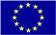  The Programme is imple-mented by the Consortium of partners led by the State Border Guard of the Republic of Latvia:  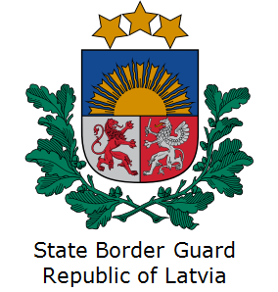 | This Programme is funded by the European Union  Delegation of the European Union to  Tajikistan  74 Adhamov street, 734013 Dushanbe  Republic of Tajikistan  Phone: +992 37 221-74-07  Fax: +992 37 221-43-321  E-mail: Delegation-Tajikistan@eeas.europa.eu | The European Union is made up of 28 Member States who have decided to gradually link together their know-how, resources and destinies. Together, during a period of enlargement of 60 years, they have built a zone of stability, democracy and sustainable development whilst maintaining cultural diversity, tolerance and individual freedoms. The European Union is committed to sharing its achievements and its values with countries and peoples beyond its borders.

