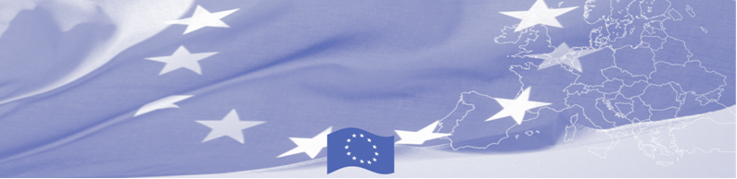
PRESS-RELEASE

The European Union Supports to Advance Skills of Customs Officials of the Central Asian States

Tashkent, 13 June 2017

On 13 June 2017 the regional seminar will be launched in Tashkent for the representatives of training institutions of the customs agencies of the Central Asian countries that is organized by the Border Management Programme in Central Asia (BOMCA) funded by the European Union. This initiative within BOMCA Programme aims to support cooperation among the law enforcement training institutions in the Central Asia region.

Participants of the seminar are tutors/instructors of the educational institutions (centers for advanced training) of customs agencies of the Central Asian states, who will discuss the issues of “Analysis of images of X-ray equipment when scanning luggage and oversized cargo”. The event will be held at the Higher Military Customs Institute of the State Customs Committee of the Republic of Uzbekistan.

This seminar will be delivered by the experts of the Higher Military Customs Institute of the State Customs Committee of the Republic of Uzbekistan, who will demonstrate the best practices of this institution in the area of introducing the newest methods and technologies for training and improving skills of customs officers associated with the recognition of images of X-ray equipment. During the seminar the participants will develop recommendations for improving the quality of training and skills of the customs officers in this area.

The Border Management Programme in Central Asia (BOMCA) launched its activities in 2003 to strengthen partnership between the Central Asian governments in the field of border management. The EU allocated more than EUR 40 mln to BOMCA for 2003-2018, while almost EUR 5 mln were assigned for implementation of the 9th phase of the programme for 2015-2018.

For more information on the event and the activity of BOMCA Programme, please visit www.bomca-eu.org, or contact Ms. Zulfiya Sibagatulina, BOMCA National Coordinator for Uzbekistan at zulfiya.sibagatulina@icmpd.org

  The Programme is imple-mented by the Consortium of partners led by the State Border Guard of the Republic of Latvia:  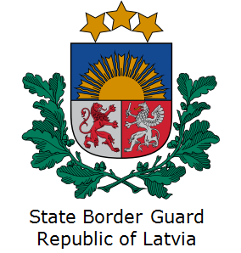 | This Programme is funded by the European Union  Delegation of the European Union to the Republic of Uzbekistan  International Business Centre,  107 B Amir Temur Street  100 084 Tashkent, Uzbekistan  Telephone: +998 71 120 16 01/02/03/04  Fax: +998 71 120 16 08  E-mail: delegation-uzbekistan@eeas.europa.eu  Website: http://www.eeas.europa.eu/delegations/uzbekistan | The European Union is made up of 28 Member States who have decided to gradually link together their know-how, resources and destinies. Together, during a period of enlargement of 60 years, they have built a zone of stability, democracy and sustainable development whilst maintaining cultural diversity, tolerance and individual freedoms. The European Union is committed to sharing its achievements and its values with countries and peoples beyond its borders.

