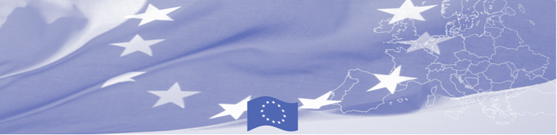
PRESS-RELEASE

European experience on ethics and professional conduct is presented to Turkmenistan’s law enforcement agencies

Ashgabat, May 29, 2017

On May 29-31, a group of European experts is visiting Ashgabat to hold a workshop for Turkmenistan’s law enforcement agencies on ethics, professional conduct and the fight against corruption. The event is organized by the Border Management Programme in Central Asia Programme (BOMCA), funded by the European Union. The invited experts together with the representatives of the law enforcement agencies will discuss the system of fighting against corruption, the standards of law enforcement ethics and professional conduct of staff in border agencies and Turkmenistan’s experience in this direction. This activity of the BOMCA Program is aimed at improving the effectiveness of the border management system in Central Asia by introducing anti-corruption measures in accordance with international law enforcement standards and norms.

European experts will present European practices in combating corruption in European border agencies, including modern methods and systems for monitoring ethical and professional conduct in border agencies (the code of ethics and its principles), will talk about relevant tools and mechanisms, provide and analyse specific examples. Turkmenistan’s experts, in their turn, will share their views on fighting corruption and practical experience in the implementation of international law enforcement standards and norms in the State bodies.

The first BOMCA operations in Central Asia began in 2003 and, since then, BOMCA has strengthened the partnership between Central Asian Governments in the field of border management. The European Union allocated a sum of EUR 40,8 million to BOMCA for the period of 2003 – 2018, out of which almost EUR 5 million were assigned to its 9th implementation phase (2015 - 2018).

For more information please contact Mr. Rustam Berdiyev, BOMCA National Coordinator for Turkmenistan, + 993 68 055707 or rustam.berdiyev.bomca@gmail.com

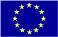  The Programme is imple-mented by the Consortium of partners led by the State Border Guard of the Republic of Latvia:  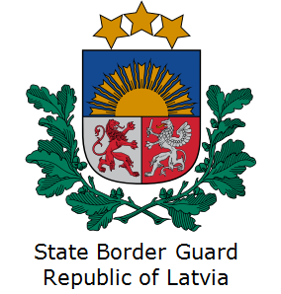 | This Programme is funded by the European Union  Delegation of the European Union to Turkmenistan  Pervy Proezd Myati Kosaeva, 8, Ashgabat. Tel: +993-12-349752  E-mail: delegation-turkmenistan@eeas.europa.eu | The European Union is made up of 28 Member States who have decided to gradually link together their know-how, resources and destinies. Together, during a period of enlargement of 60 years, they have built a zone of stability, democracy and sustainable development whilst maintaining cultural diversity, tolerance and individual freedoms. The European Union is committed to sharing its achievements and its values with countries and peoples beyond its borders.

