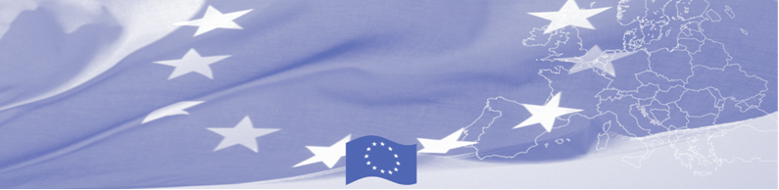
PRESS-RELEASE

E-customs and its advantages are in the focus of European advisory mission

For release on May 02, 2017

EU is continuing to offer significant support to trade facilitation activities in Central Asia. Thus, a technical assistance mission on E-Customs starts in Ashgabat on May 02, 2017 within the framework of Border Management Programme in Central Asia (BOMCA), funded by the European Union. International and local experts will gather together to discuss the importance of the use of modern technologies in the Customs environment and how Turkmen Customs had implemented several electronic services to improve its business processes. This BOMCA activity is aimed to the establishment of proper national policies for the development of e-customs environment in Central Asian countries.

European experts will introduce advanced practices on international and regional developments, including opportunities, challenges and potential solutions in the area of cross-border e-commerce and Digital Customs, present related tools and instruments, country examples and case studies. Representatives of the State Customs Service of Turkmenistan in their turn will share their perspective and visions, in particular how they were adapting to the growing e-commerce environment, practical experiences and best practices relating to the implementation of various IT solutions in Turkmenistan`s customs.

The first BOMCA operations in Central Asia began in 2003 and, since then, BOMCA has strengthened the partnership between Central Asian Governments in the field of border management. The European Union allocated a sum of EUR 40,8 million to BOMCA for the period of 2003 – 2018, out of which almost EUR 5 million were assigned to its 9th implementation phase (2015 - 2018).

For more information please contact Mr. Rustam Berdiyev, BOMCA National Coordinator for Turkmenistan, + 993 68 055707 or rustam.berdiyev.bomca@gmail.com

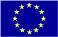  The Programme is imple-mented by the Consortium of partners led by the State Border Guard of the Republic of Latvia:  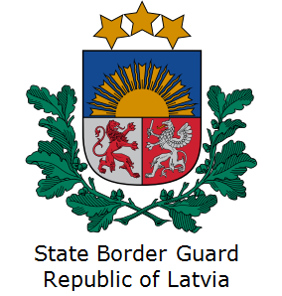 | This Programme is funded by the European Union  Delegation of the European Union to Turkmenistan  Pervy Proezd Myati Kosaeva, 8, Ashgabat. Tel: +993-12-349752  E-mail: delegation-turkmenistan@eeas.europa.eu | The European Union is made up of 28 Member States who have decided to gradually link together their know-how, resources and destinies. Together, during a period of enlargement of 60 years, they have built a zone of stability, democracy and sustainable development whilst maintaining cultural diversity, tolerance and individual freedoms. The European Union is committed to sharing its achievements and its values with countries and peoples beyond its borders.

