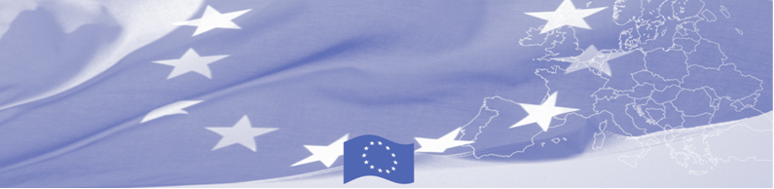
PRESS RELEASE

Assessing Kyrgyzstan’s capacities in compliance with GSP+ provisions and requirements

Bishkek, March 28, 2017

EU is continuing to offer significant support to trade facilitation activities in Central Asia. Thus, a technical assistance mission on GSP+ will be held in Bishkek on March 28 - 31, 2017 within the framework of Border Management Programme in Central Asia (BOMCA), funded by the European Union. Four European experts will meet partners from Ministry of Economy, State Customs Service, Chamber of Commerce and Industry, Ministry of Agriculture, State Inspectorate on Veterinary and Phytosanitary Safety in order to assess the current state of play and provide recommendations for further implementation of GSP+ provisions.

From January 2016 the Kyrgyz Republic benefits from the EU's Generalized System of Preferences (GSP), a bilateral trade arrangement through which the EU provides preferential access to its market to developing countries and territories, in the form of reduced tariffs for their goods when entering the EU market

In particular, experts will assess the situation in issuance and control of certificates of origin, veterinary and phytosanitary certificates and quality certificates. Based on Mission’s findings, the set of recommendations will be developed on further implementation of GSP+ provisions and shared with the Government of the Kyrgyz Republic.

The workshop will promote EU import standards and raise awareness of the gaps and needs regarding the technical capacities required to export national products to EU MS. In addition, the participants will get acquainted with rules of origin of EU and learn the practices of Lithuanian Customs in issuance and control of certificates of preferential origin.

The first BOMCA operations in Central Asia began in 2003 and, since then, BOMCA has strengthened the partnership between Central Asian Governments in the field of border management. The European Union allocated a sum of EUR 40, 8 million to BOMCA for the period of 2003 – 2018, out of which almost EUR 5 million were assigned to its 9th implementation phase (2015 - 2018).

For more information, please visit web-site www.bomca-eu.org or contact Ms. Janna Tashieva, BOMCA National Coordinator for Kyrgyzstan – janna.tashieva@icmpd.org

  The Programme is implemented by the Consortium of partners led by the State Border Guard of the Republic of Latvia:  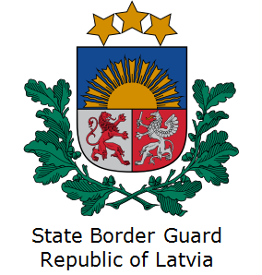 | This Programme is funded by the European Union  Delegation of the European Union to the Kyrgyz Republic  21 Erkindik Boulevard, Business Centre Orion, 5th floor  Bishkek, 720040, Kyrgyz Republic  Telephone: +996 312 26 10 00  Fax: +996 312 26 10 07  E-mail: delegation-kyrgyzstan@eeas.europa.eu  Website:http://eeas.europa.eu/delegations/kyrgyzstan  Facebook: http://www.facebook.com/eudelkg | The European Union is made up of 28 Member States who have decided to gradually link together their know-how, resources and destinies. Together, during a period of enlargement of 60 years, they have built a zone of stability, democracy and sustainable development whilst maintaining cultural diversity, tolerance and individual freedoms. The European Union is committed to sharing its achievements and its values with countries and peoples beyond its borders.

