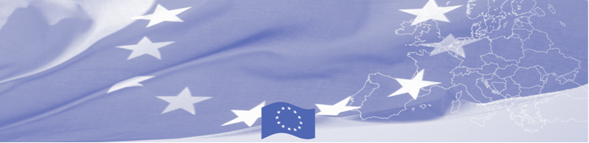
PRESS RELEASE

For release on January 24 , 2017

BOMCA 9 supports professionalism in travellers profiling and identification

The EU is continuing to offer significant support to border security activities in Central Asia. In particular, on January 24 – 26 Ashgabat will host the National workshop on identification and profiling techniques, conducted within the framework of the EU-funded Border Management in Central Asia Programme (BOMCA 9). The workshop, facilitated by the EU expert from the State Border Guard of Latvia, will gather border guards and other law enforcement professionals of Turkmenistan, involved in profiling and identification of different groups and categories of travelers. In 2016, BOMCA conducted 5 events in Turkmenistan, covering more than 50 participants and more than 10 participants joined regional workshops.

This workshop is a part of BOMCA 9 activity directed to improvement of legal and procedural instruments of Central Asian agencies in facing challenges in identification of persons which may pose a risk to the public order and security. It aims to present EU good practices in the area of identification and profiling of different groups of travelers and to introduce modern mechanisms in profiling different categories of persons crossing the state border. The workshop participants will exchange experience and best practices on profiling and its main modern directions and approaches to travellers identification at the border crossing points, including criminal profiling, information comparative analysis, documents check and profile development methods.

Such workshops are being conducted in all 5 Central Asian countries. Based on the workshop in Turkmenistan results the EU experts will develop recommendations for aligning existing profiling and identification mechanisms at the national level with the international advanced standards and practices.

The first BOMCA operations in Central Asia began in 2003 and, since then, BOMCA has strengthened the partnership between Central Asian Governments in the field of border management. The European Union allocated a sum of EUR 40,8 million to BOMCA for the period of 2003 – 2018, out of which almost EUR 5 million were assigned to its 9th implementation phase (2015 - 2018).

For more information please contact Mr. Rustam Berdiyev, BOMCA National Coordinator for Turkmenistan, – + 993 68 055707 or rustam.berdiyev.bomca@gmail.com
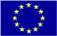  The Programme is imple-mented by the Consortium of partners led by the State Border Guard of the Republic of Latvia:  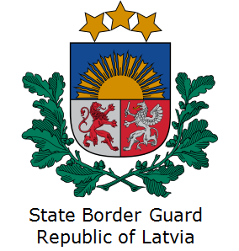 | This Programme is funded by the European Union  Delegation of the European Union to the Republic of Turkmenistan  Pervy Proezd Myati Kosaeva, 8, Ashgabat. Tel: +993-12-349752  E-mail: delegation-turkmenistan@eeas.europa.eu | The European Union is made up of 28 Member States who have decided to gradually link together their know-how, resources and destinies. Together, during a period of enlargement of 60 years, they have built a zone of stability, democracy and sustainable development whilst maintaining cultural diversity, tolerance and individual freedoms. The European Union is committed to sharing its achievements and its values with countries and peoples beyond its borders.

