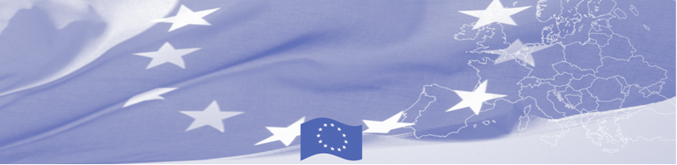
PRESS RELEASE

Border Management in Central Asia Programme (BOMCA)
sums up the achievements to date and outlines plans for the future

Bishkek, November 29, 2016

On November 29, Bishkek will host the 2nd Regional Steering Group meeting of the European Union funded BOMCA 9 Programme. Representatives of border and customs services, Foreign Ministries, and migration management agencies of all Central Asian countries, as project beneficiaries, together with BOMCA Consortium partners and representatives of the Delegation of the European Union to the Kyrgyz Republic will gather in Bishkek in order to jointly assess Programme achievements, successes and challenges to date, and discuss the work plan for the next year. Furthermore, the meeting will touch upon the overall national priorities for the upcoming years to explore further possible support to the region. The meeting will be chaired by Mr. Damir Sagynbaev, Head of Defence, Law Enforcement and Emergencies Department of the Kyrgyz Government Office.

Since its start in 2003, BOMCA has been one of the foremost examples of EU cooperation with all Central Asian countries in the area of border management and cross-border cooperation. The 9th phase of BOMCA builds upon the results and achievements of the previous decade of work in the region and specifically targets the areas of institutional development, management of mixed migration flows and trade facilitation. Currently, BOMCA 9 is on its halfway - starting from June 2015, over 900 beneficiaries from 5 Central Asian countries have participated in more than 60 events of different scope – from national and regional workshops to technical assistance missions and study visits to the EU Member States. Up to its completion, the 9th phase of BOMCA intends to conduct almost 100 additional activities, including the delivery of technical equipment to all five CA border agencies for the total amount of EUR 240 000 in 2017.

The first BOMCA operations in Central Asia began in 2003 and, since then, BOMCA has strengthened the partnership between Central Asian Governments in the field of border management. The European Union allocated a sum of EUR 40,8 million to BOMCA for the period of 2003 – 2018, out of which almost EUR 5 million were assigned to its 9th implementation phase (2015 - 2018).

For more information, please visit web-site www.bomca-eu.org or contact Ms. Janna Tashieva, BOMCA National Coordinator for Kyrgyzstan – janna.tashieva@icmpd.org
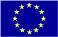  The Programme is implemented by the Consortium of partners led by the State Border Guard of the Republic of Latvia:  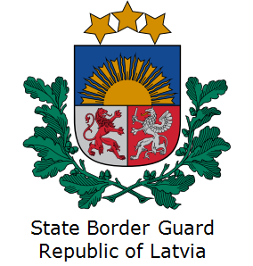 | This Programme is funded by the European Union  Delegation of the European Union to the Kyrgyz Republic  21 Erkindik Boulevard, Business Centre Orion, 5th floor  Bishkek, 720040, Kyrgyz Republic  Telephone: +996 312 26 10 00  Fax: +996 312 26 10 07  E-mail: delegation-kyrgyzstan@eeas.europa.eu  Website:http://eeas.europa.eu/delegations/kyrgyzstan  Facebook: http://www.facebook.com/eudelkg | The European Union is made up of 28 Member States who have decided to gradually link together their know-how, resources and destinies. Together, during a period of enlargement of 60 years, they have built a zone of stability, democracy and sustainable development whilst maintaining cultural diversity, tolerance and individual freedoms. The European Union is committed to sharing its achievements and its values with countries and peoples beyond its borders.

